

|  |  |  |
| --- | --- | --- |
| **Subject** | **:** | Switching and Routing Essential |
| **Intake Code** | **:** | APU2F2502CS(CYB) |
| **Lecturer Name** | **:** | Joshua Samual |
| **Hand in Date** | **:** | Week-13 |
| **Hand Out Date** | **:** | Week-3 |
| **Project Title** | **:** | Network Upgrades for Cloud Co |
| **Group Leader** | **:** | Er Chen Liang |

|  |  |
| --- | --- |
| **Student ID** | **Student Name** |
| TP080254 | Er Chen Liang |
| TP077723 | Huang XiaoShun |
| TP080388 | Chong Wai Kit |

**Table of Contents**

1.0 Introduction 3

2.0 Network Layout 4

3.0 IPv4 Addressing Table 6

4.0 LAN and WAN Configuration 8

4.1 LAN Configuration 8

4.2 WAN Configuration 20

5.0 WLAN Architecture 28

6.0 EtherChannel Implementation 53

7.0 HSRP Implementation 58

8.0 Configure Server Service in Server Farm 61

9.0 Ping commands to proof that the network are interconnected 68

10.0 Basic Security Mechanisms Implementation 80

11.0 Recommendations to Improve the Security Mechanisms 101

12.0 Conclusion 102

13.0 Work Breakdown Structure 103

14.0 Reference 104

1. Introduction

Cloud Co is a global networking company which operating with the centralized headquarters in Kuala Lumpur (KL), Malaysia, and branch offices in Australia and Singapore. It has initiated a comprehensive network upgrade project focusing on switching and routing technologies to enhance the overall performance and security. At this core of the project is to redesign of the VLAN architecture across all of the sites to reduce the broadcast domains, improve traffic isolation, and enhance network policy enforcement using Layer 2 and Layer 3 switching techniques.

At the Australian branch, a Wireless LAN Controller (WLC) is used to centralize the wireless light-weight access point (LAP) management. This deployment supports features such as seamless roaming and dynamic VLAN assignment. Also, they will enhance the WLAN security through the WPA2 policy. Routing protocols will be redesigned to ensure the efficiency of the inter-VLAN communication and the WAN routing between sites.

This assignment includes switch and router configuration, including VLAN design, trunking strategy, inter-VLAN routing, wireless controller integration, and implementation of security mechanisms such as ACLs and port security. By implementing these technologies, student can gain close to real hands-on experience to give ourselves a foundation for future work.

1. Network Layout

This is the re-designed Network Layout of the Cloud Co. This network design illustrates a multi-branch enterprise setup that helps an international organisation in Kuala Lumpur (KL Branch) and its branches in Singapore and Australia function properly. The architecture shows how it is easy to scale and maintain, as the design emphasises separation of services, high availability and strong connexions between branches.

Basically, the three VLANs (Management, HR, Design) for the branch’s departments, making them isolated for protection and performance and linking them with Layer 2 and Layer 3 switching technologies. HSRP makes it possible to use redundant routers so that default gateways always stay available for end devices, avoiding interruptions if a router fails.

Both core and backup links run through the WAN connexions that attach the KL, Singapore and Australia branches, making sure there is constant communication. Every branch sets up its own LAN and uses multiple subnets for different departments which helps maintain order and control over the network’s data flow. The network is secured by putting port security, SSH access and other best practises in place to defend important information from unauthorised access.

It follows the best standards in enterprise network design, focusing mainly on how reliable, safe and easy to maintain it is. It is suitable for companies that need easy teamwork, reliability and advanced security measures in different locations.

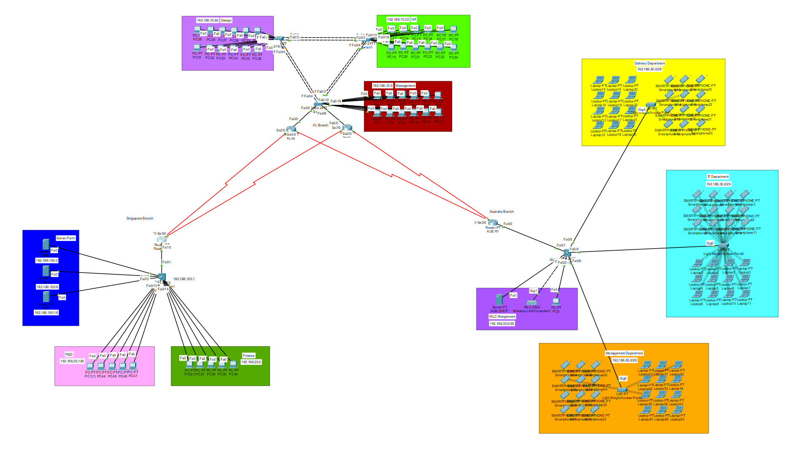

Network Layout 1

1. IPv4 Addressing Table

Australia Branch Private IP

|  |  |  |  |  |  |
| --- | --- | --- | --- | --- | --- |
| Network | Device Count | Subnet Address | Usable IP Range | CIDR | Subnet Mask |
| WLC Management & IT Department | 28 | 192.168.30.0 | 192.168.30.1 -  192.168.30.126 | /25 | 255.255.255.128 |
| Delivery Department | 25 | 192.168.40.0 | 192.168.40.1 - 192.168.40.62 | /26 | 255.255.255.192 |
| Management Department | 25 | 192.168.50.0 | 192.168.50.1 - 192.168.50.62 | /26 | 255.255.255.192 |

* The reason using this large of unused IP is because of the DHCP sometimes bug in cisco. It will skip by a large number to another devices.

KL Branch Private IP

|  |  |  |  |  |  |
| --- | --- | --- | --- | --- | --- |
| Network | Device Count | Subnet Address | Usable IP Range | CIDR | Subnet Mask |
| Management Department | 12 | 192.168.10.0 | 192.168.10.1- 192.168.10.30 | /27 | 255.255.255.224 |
| Human Resource Department | 12 | 192.168.10.32 | 192.168.10.33- 192.168.10.62 | /27 | 255.255.255.224 |
| Design Department | 12 | 192.168.10.64 | 192.168.10.65- 192.168.10.94 | /27 | 255.255.255.224 |

Singapore Branch Private IP

|  |  |  |  |  |  |
| --- | --- | --- | --- | --- | --- |
| Network | Device Count | Subnet Address | Usable IP Range | CIDR | Subnet Mask |
| R&D  Department | 8 | 192.168.20.0 | 192.168.20.1 - 192.168.20.6 | /28 | 255.255.255.240 |
| Finance Department | 8 | 192.168.30.128 | 192.168.30.129 - 192.168.30.142 | /28 | 255.255.255.240 |
| Server  DNS  FTP | 3 | 192.168.100.0 | 192.168.100.1-  192.168.100.6 | /29 | 255.255.255.248 |

Public IP

|  |  |  |  |  |  |
| --- | --- | --- | --- | --- | --- |
| Network | Device Count | Subnet Address | Usable IP Range | CIDR | Subnet Mask |
| Australia and KL | 2 | 10.0.0.0 | 10.0.0.1 – 10.0.0.2 | /30 | 255.255.255.252 |
| Australia and KL | 2 | 11.0.0.0 | 11.0.0.1 – 11.0.0.2 | /30 | 255.255.255.252 |
| Singapore and KL | 2 | 12.0.0.0 | 12.0.0.1 – 12.0.0.2 | /30 | 255.255.255.252 |
| Singapore and KL | 2 | 13.0.0.0 | 13.0.0.1 – 13.0.0.2 | /30 | 255.255.255.252 |

1. LAN and WAN Configuration

## 4.1 LAN Configuration

**KLS1**

This is the configuration of KL branch switch 1 (KL Management). Create new 3 VLAN which are 70 (KL Management), 80 (KL Human Resource), 90 (KL Design). After that, config the port-security to restrict and control the number of devices, which is mac-address.

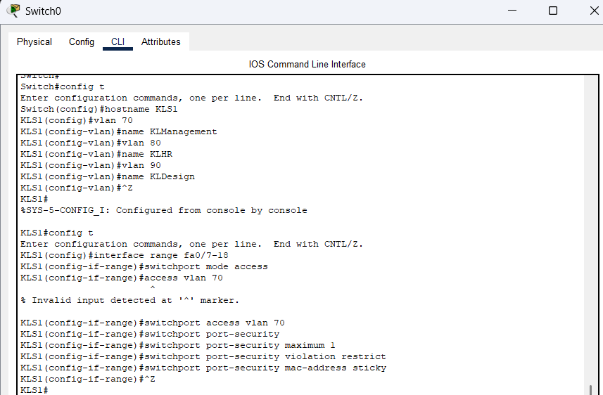

LAN Config 1

After that, create the SSH in this switch to encrypt the connection and secure network protocol that used to remotely access and manage network devices.

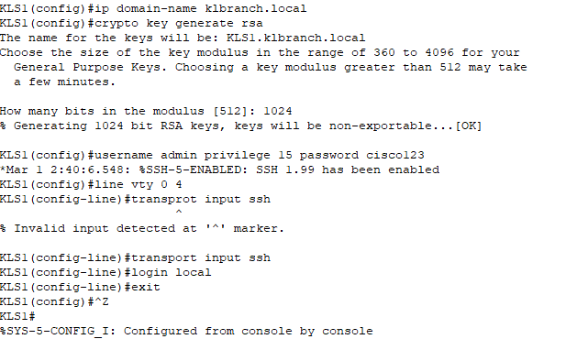

LAN Config 2

**KLS2**

This is the configuration of KL branch switch 2 (KL Human Resources). Create the VLAN for each department by following last switch and set up the port-security and SSH.

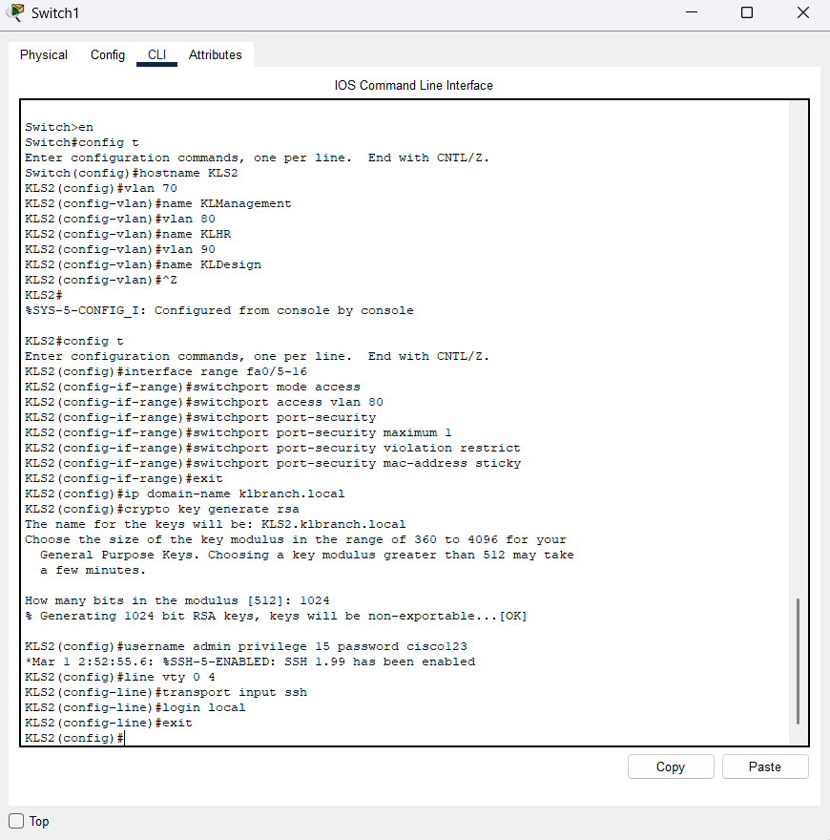

LAN Config 3

**KLS3**

This is the configuration of KL branch switch 3 (KL Design). In this switch, it also needs to config the VLAN and set up the port-security and SSH.

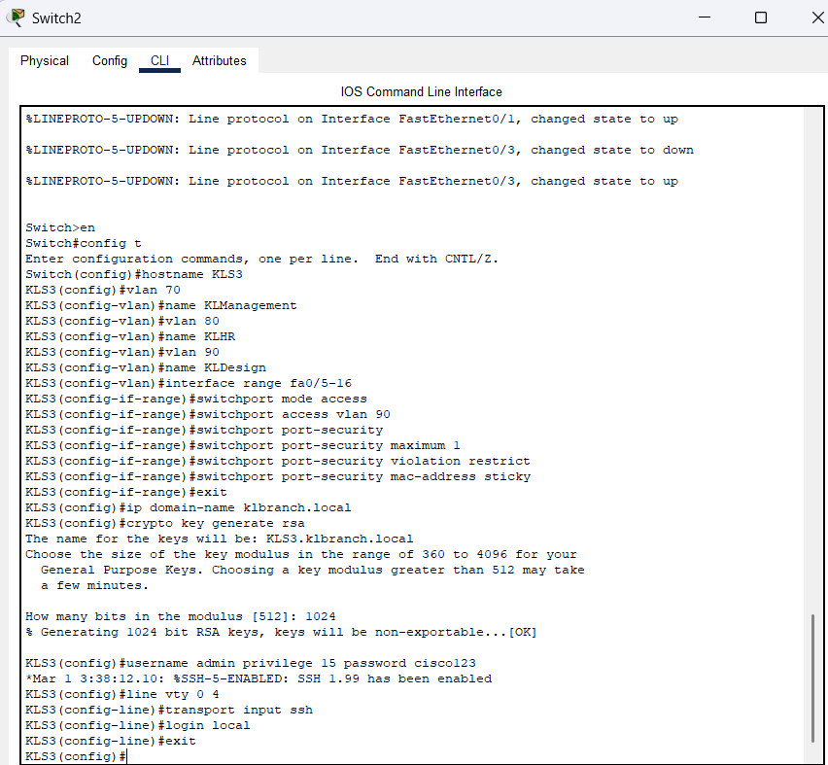

LAN Config 4

**KLR1**

This is the configuration of KL branch Router 1 (Standby), this configuration will enable VLAN to be tagging for inter-VLAN routing. It will let the router to route packets by using the following interfaces.

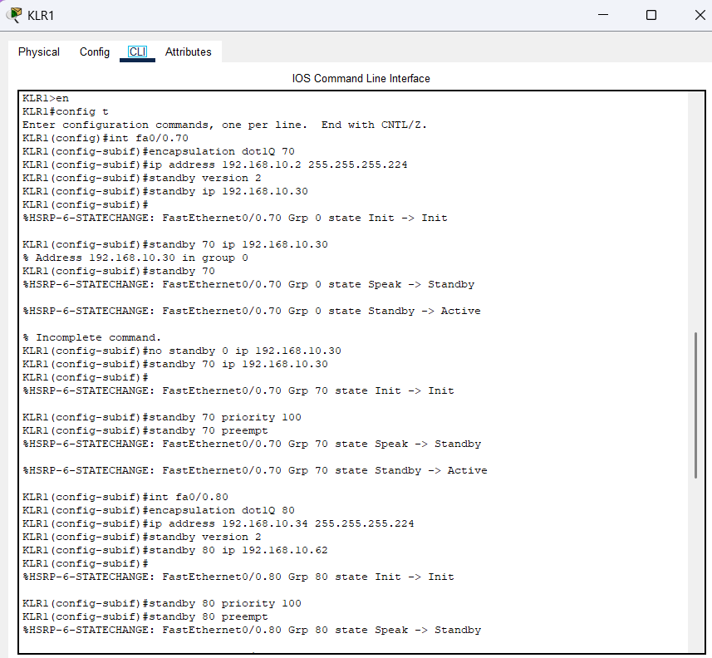

LAN Config 5

After config the router-on-a-stick sub interfaces, it also needs to create a SSH for this router.

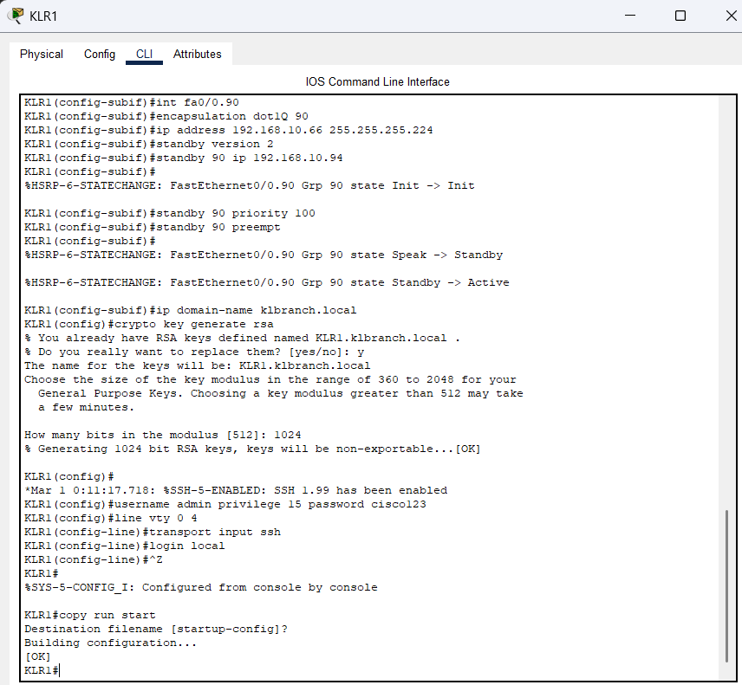

LAN Config 6

**Static Routing**

This is the static routing configuration of the KLR1. It can help prevent incorrect routes from entering routing table.

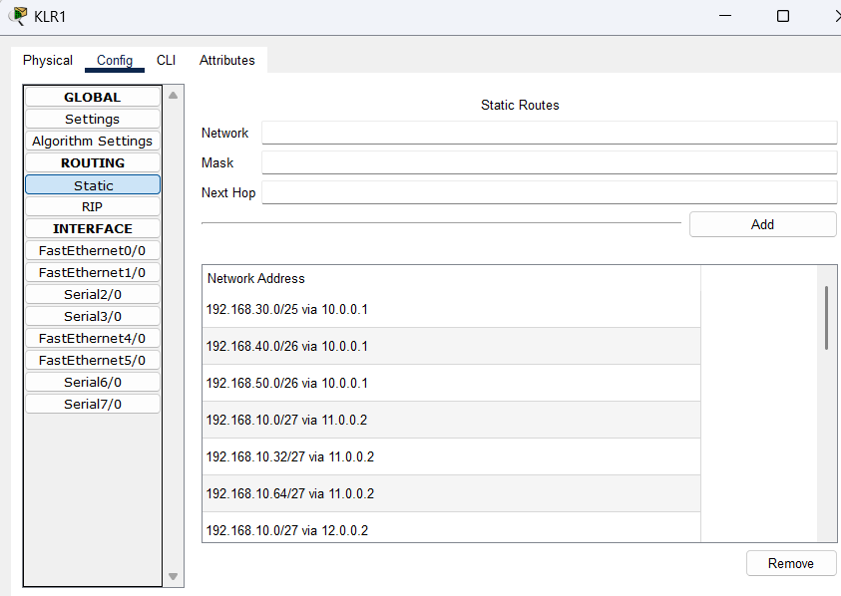

LAN Config 7

**OSPF**

This is the OSPF configuration in the KLR1. It can advertise and learn routes automatically, so that it can make all branches and departments reachable without static routes.

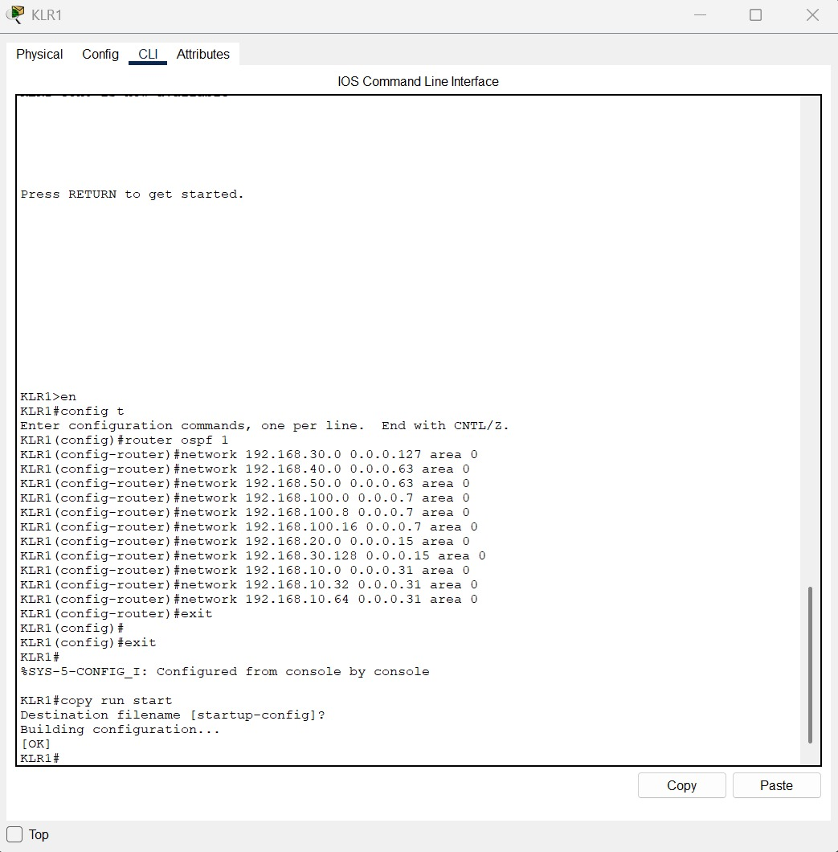

LAN Config 8

**KLR2**

This is the configuration of KL branch Router 2 (Active), this router is the main router to connecting with Singapore branch and Australia branch.

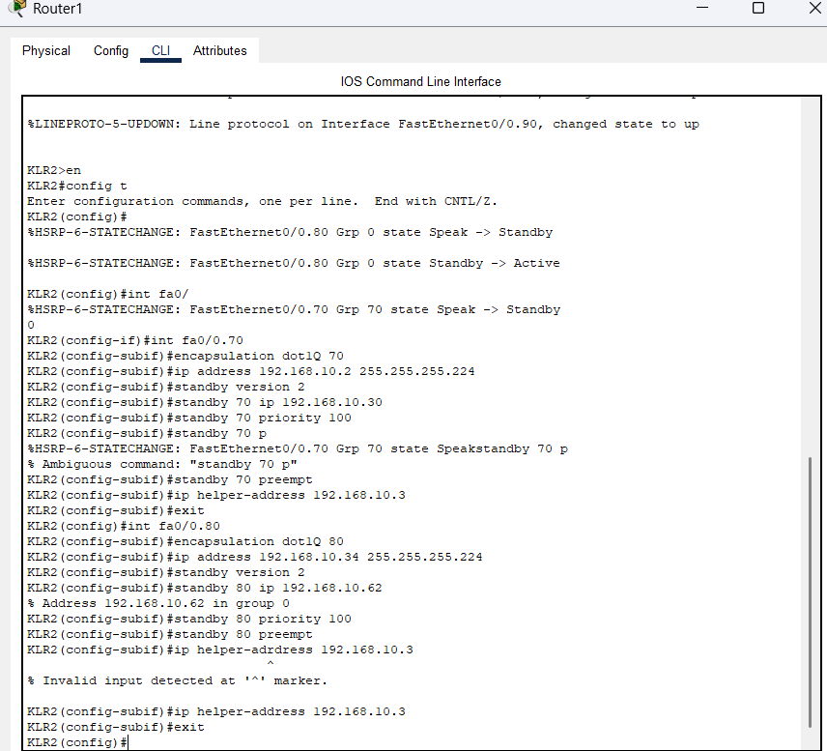

LAN Config 9

After finishing the configuration, create a SSH for this router is necessary.

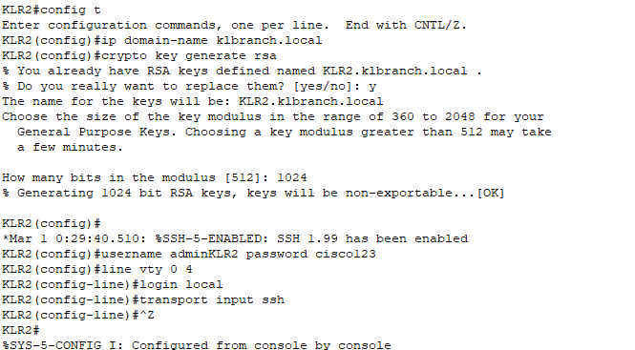

LAN Config 10

**Static Routing**

This is the static routing configuration of KLR1.

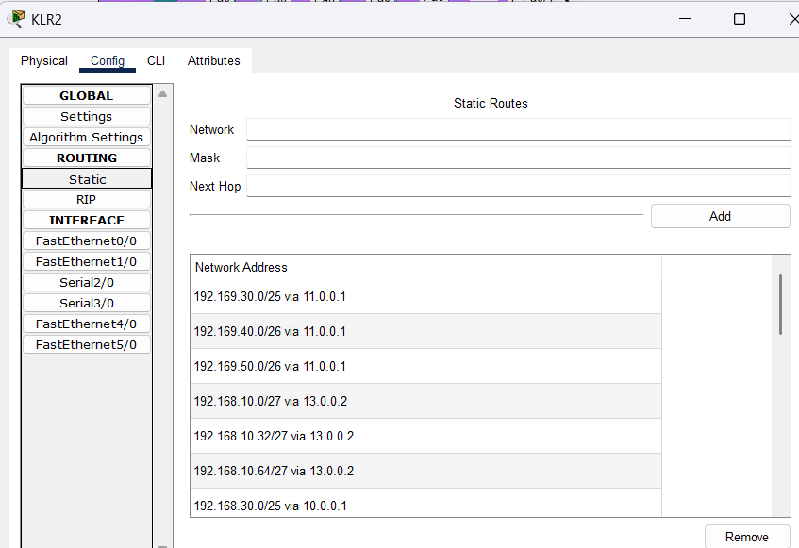

LAN Config 11

**OSPF**

This is the OSPF configuration for KLR2, make sure all of the Ip address have been configured into the router.

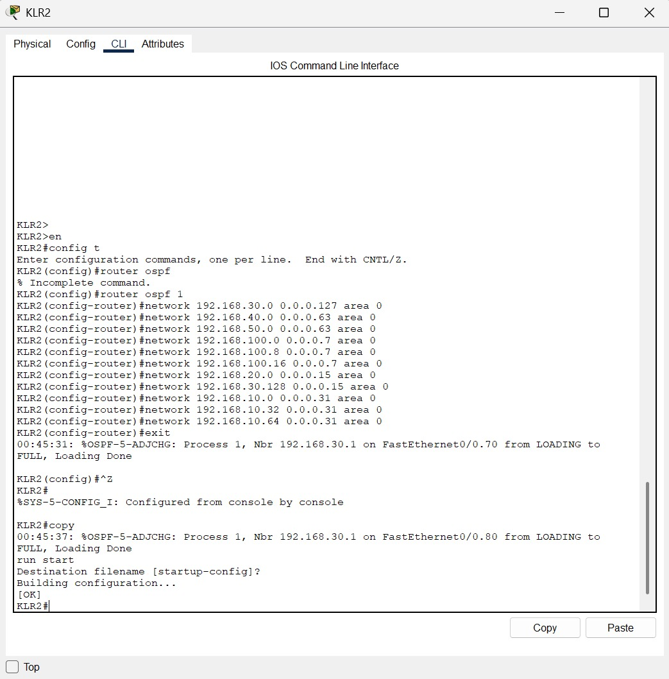

LAN Config 12

## 4.2 WAN Configuration

**AUS S0**

This is the configuration of the Australia branch of AUS S0(Australia Switch 0) which create each VLANs and assign VLANs to each port.  
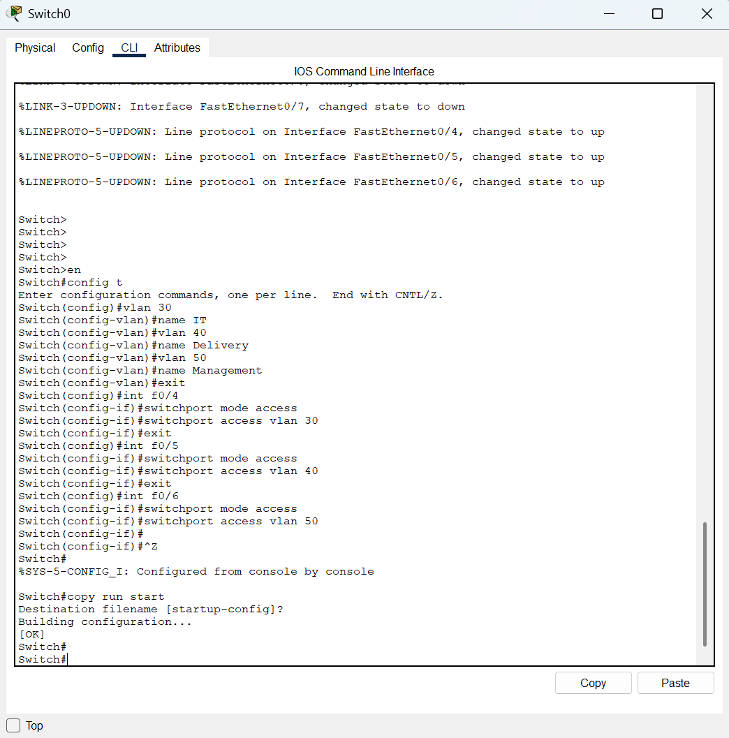

WAN Config 1

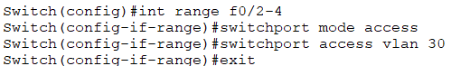

WAN Config 2

This the configuration of switching the switch port mode to trunk port which can enable the VLANs can communicate between the router and switch.

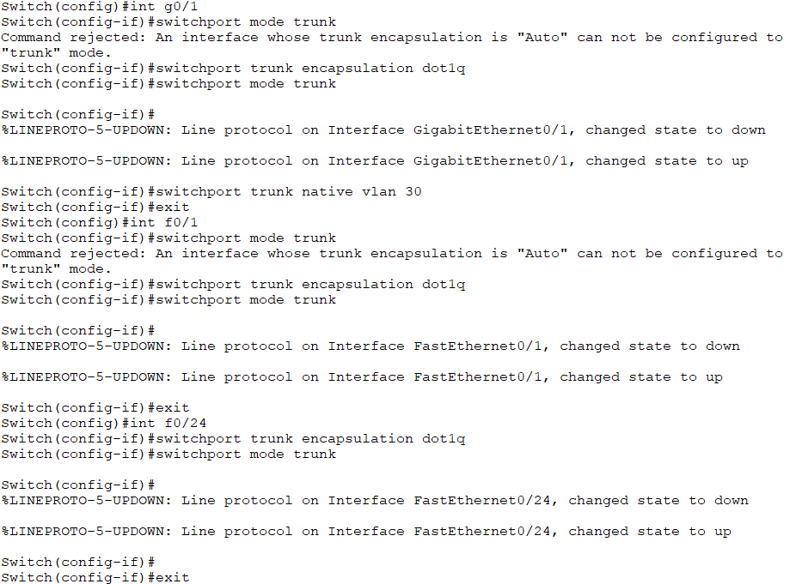

WAN Config 3

After assign each VLANs to the interface, config each VLANs IP address to them.

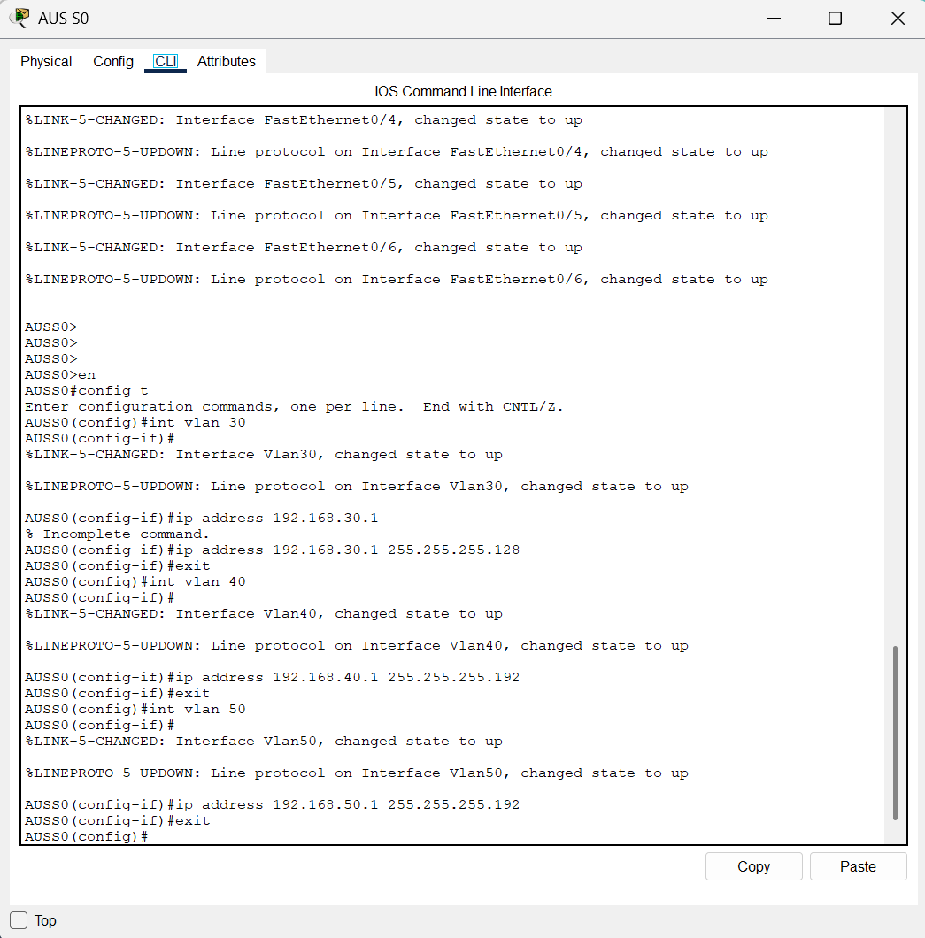

WAN Config 4

**AUS R1**

This is the configuration of the Australia branch of AUS R1(Australia Router 1) with each sub-interface is assigned an IP address and a helper-address by using the **Router-on-a-stick** configuration.

**AUSR1**

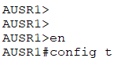

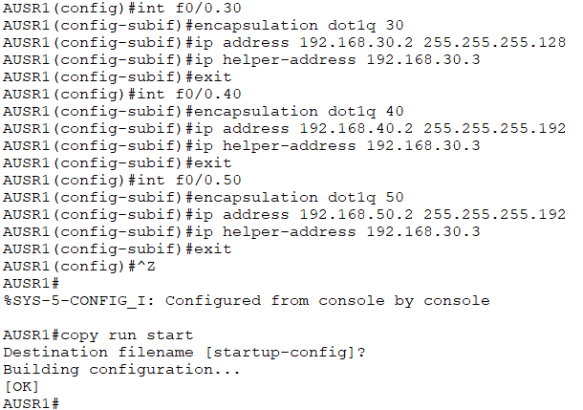

WAN Config 5

As the AUS R1(Australia Router 1) use the IP address of 192.168.30.2

Next, configure the static routing of the Router

**AUSR1**

Setting the IP route between the KL router and the AUSR1(Australia Router 1).

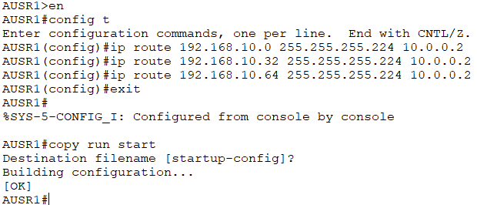

WAN Config 6

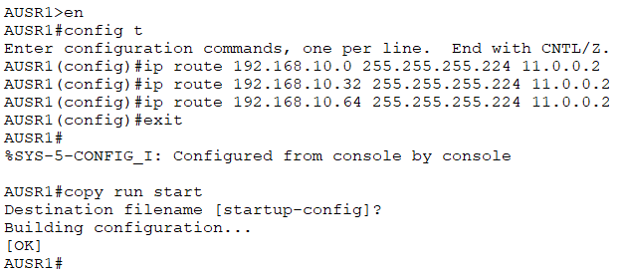

WAN Config 7

Setting the IP route between the Singapore router and the AUSR1(Australia Router 1).

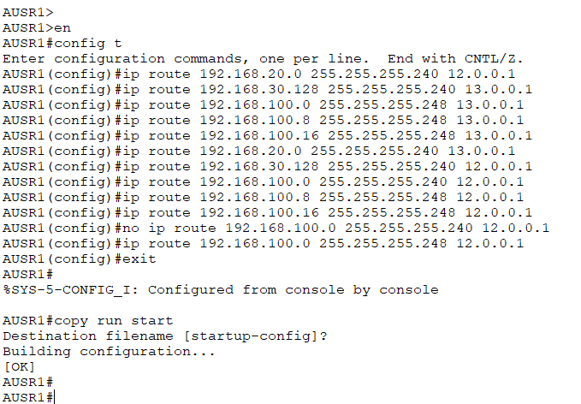

WAN Config 8

Now is the configuration of the OSPF.

**AUSR1**

Setting the network address between the KL Router with the area of 0.

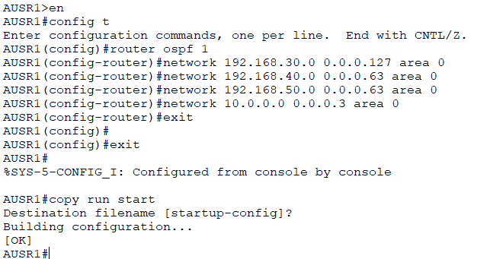

WAN Config 9

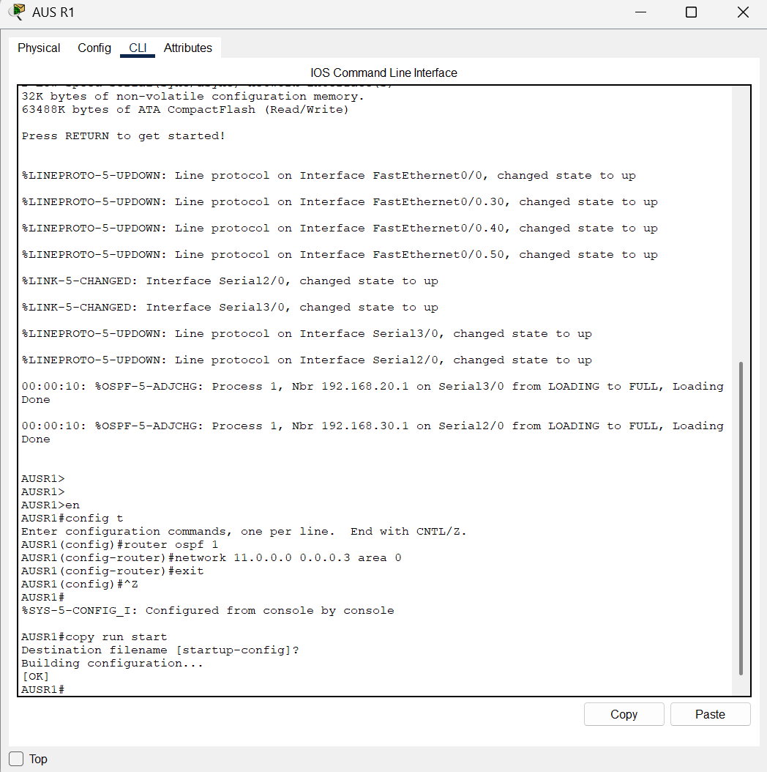

WAN Config 10

After setting up all of the static routing and OSPF the Australia part can communicate with the KL branch.

Setting the network address between the KL Router with the area of 0.

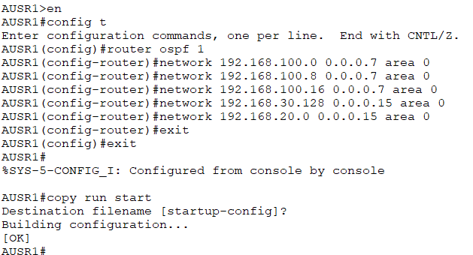

WAN Config 11

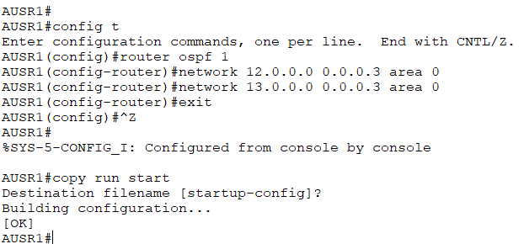

WAN Config 12

After setting up all of the static routing and OSPF the Australia part can communicate with the Singapore branch.

1. WLAN Architecture

**Australia Branch**

First, set the static IP address of the DHCP server, WLC Controller, and the WLC Management PC.

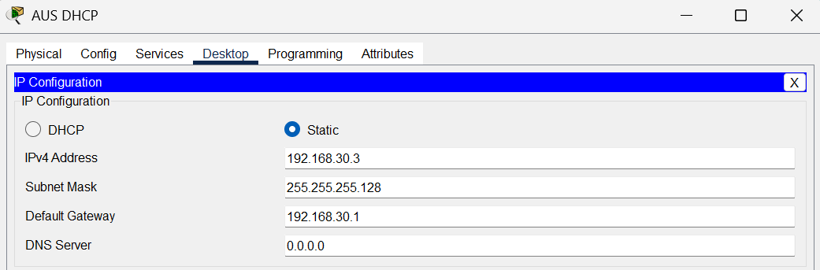

WLAN Architecture 1

This is the WLC Controller IP address.

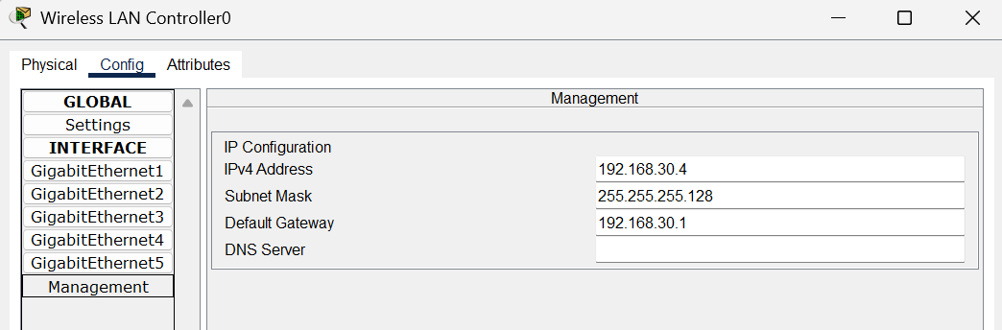

WLAN Architecture 2

And also, the PC IP address to enable the PC can open the GUI of the WLC Controller.

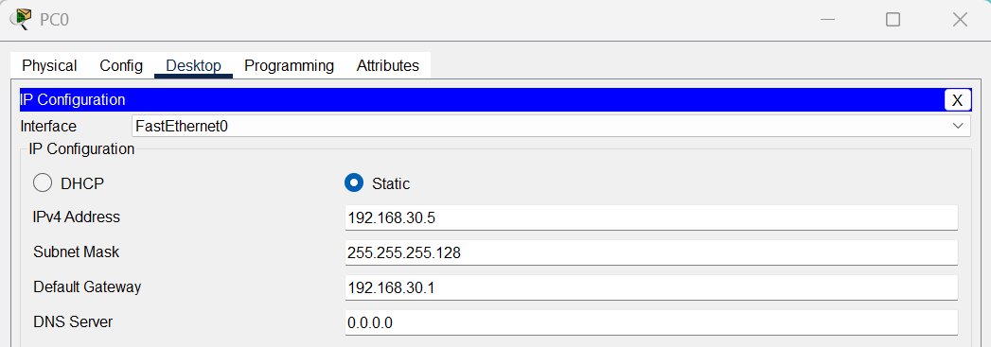

WLAN Architecture 3

Then, create the DHCP Pool of the IT Department, Management Department, and Delivery Department in the DHCP server.

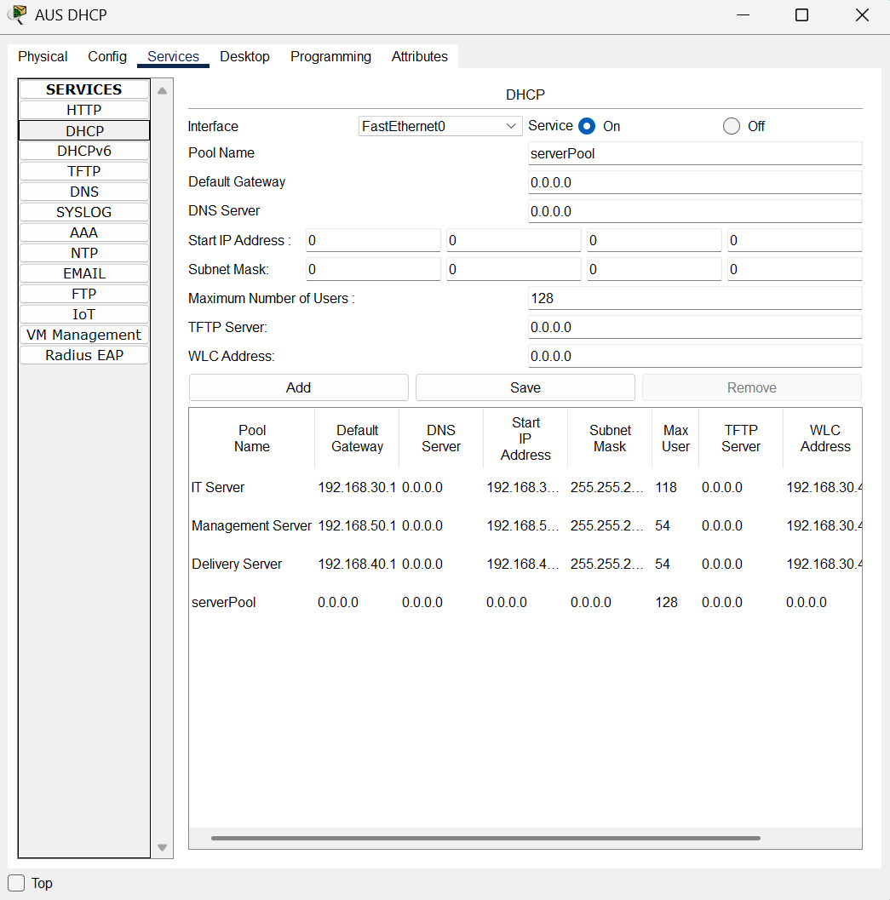

WLAN Architecture 4

Go to the WLC Management pc and go to the Desktop and click on the Web Browser. Next, type http://(IP of the WLC Controller) at the URL and register the account.

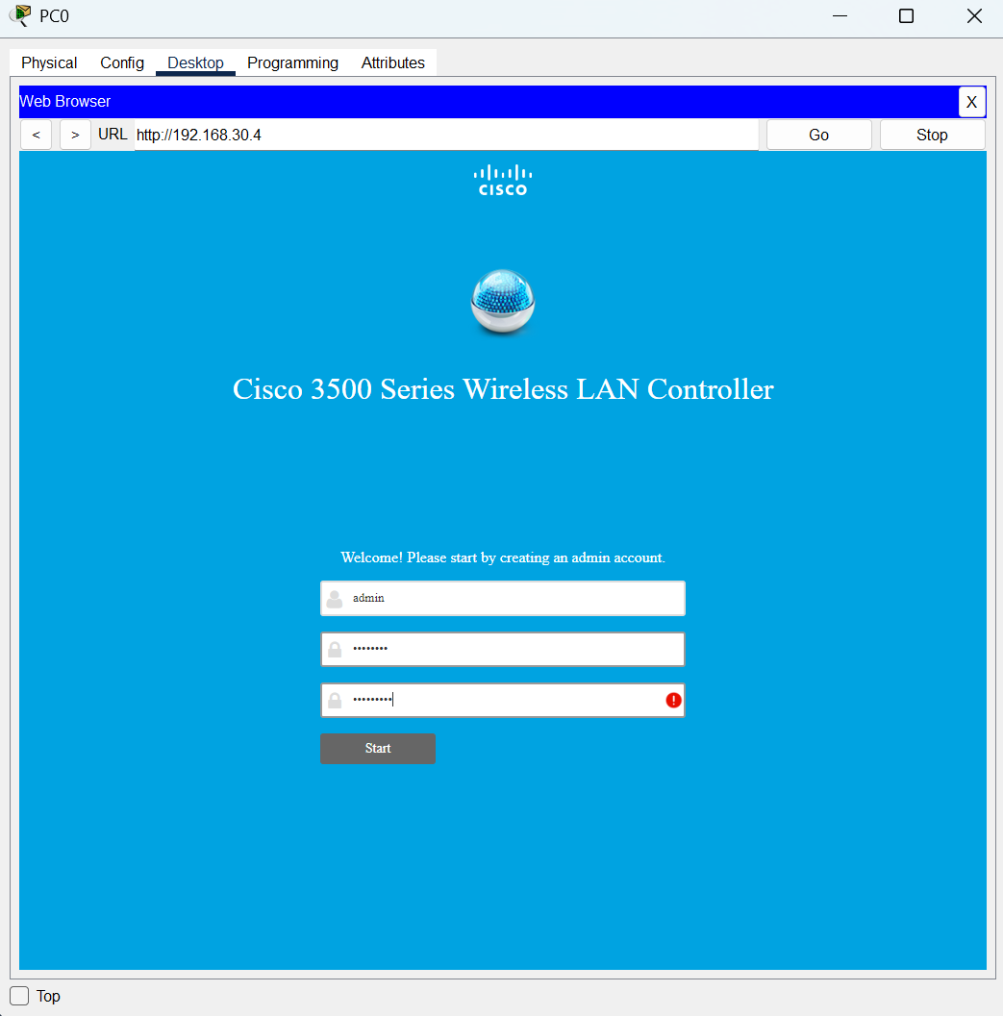

WLAN Architecture 5

After that, set up the system name of the WLC Controller, IP address of the WLC Controller, Subnet Mask and the Default gateway. When the controller set-up is done, click on the Next button to proceed.

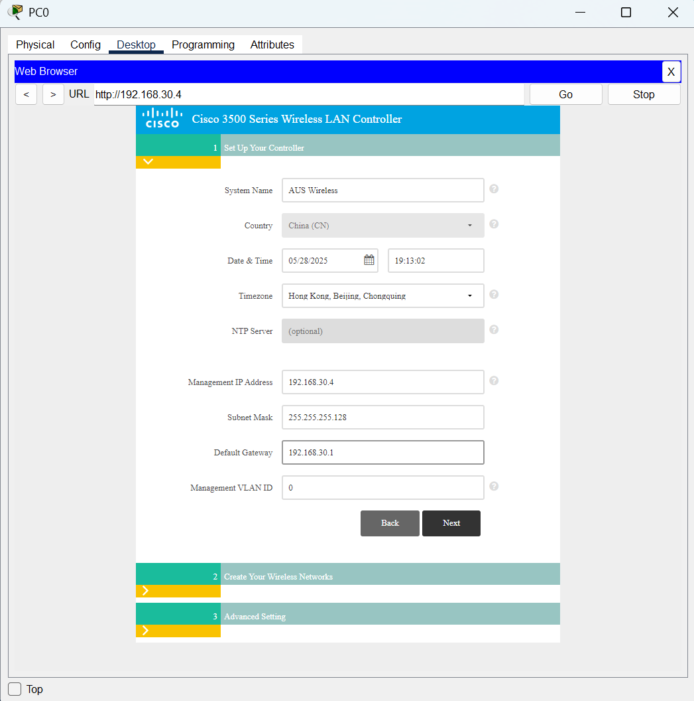

WLAN Architecture 6

To create the first network, type in the network name and the passphrase of the network. Then, click on the Next button to procced.

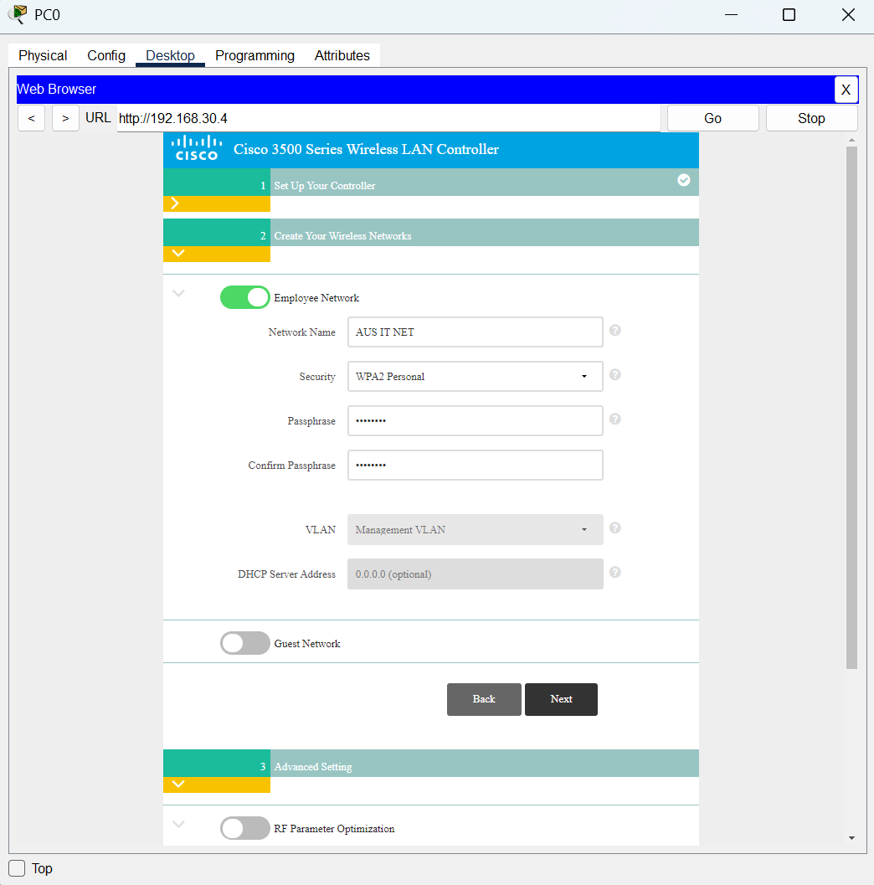

WLAN Architecture 7

Click on the Next button to skip the Advance Setting.

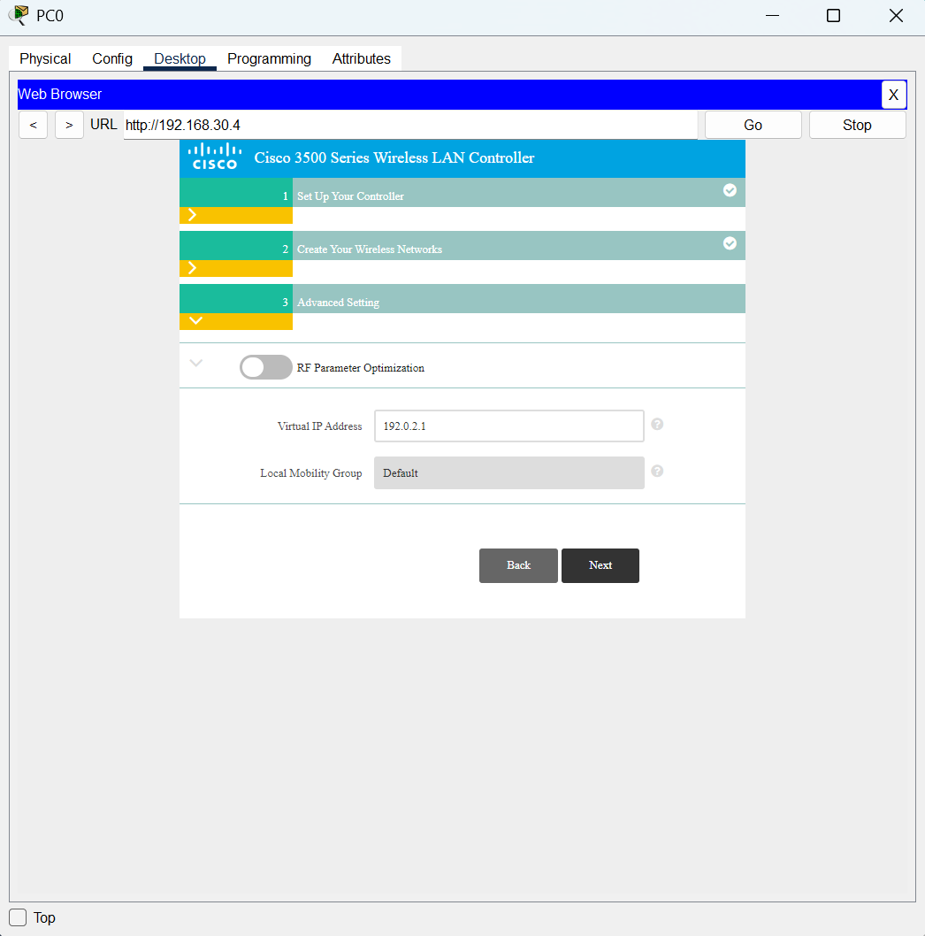

WLAN Architecture 8

It will come to this page after who skipped the Advance Setting, click on the Apply button to apply all the settings.

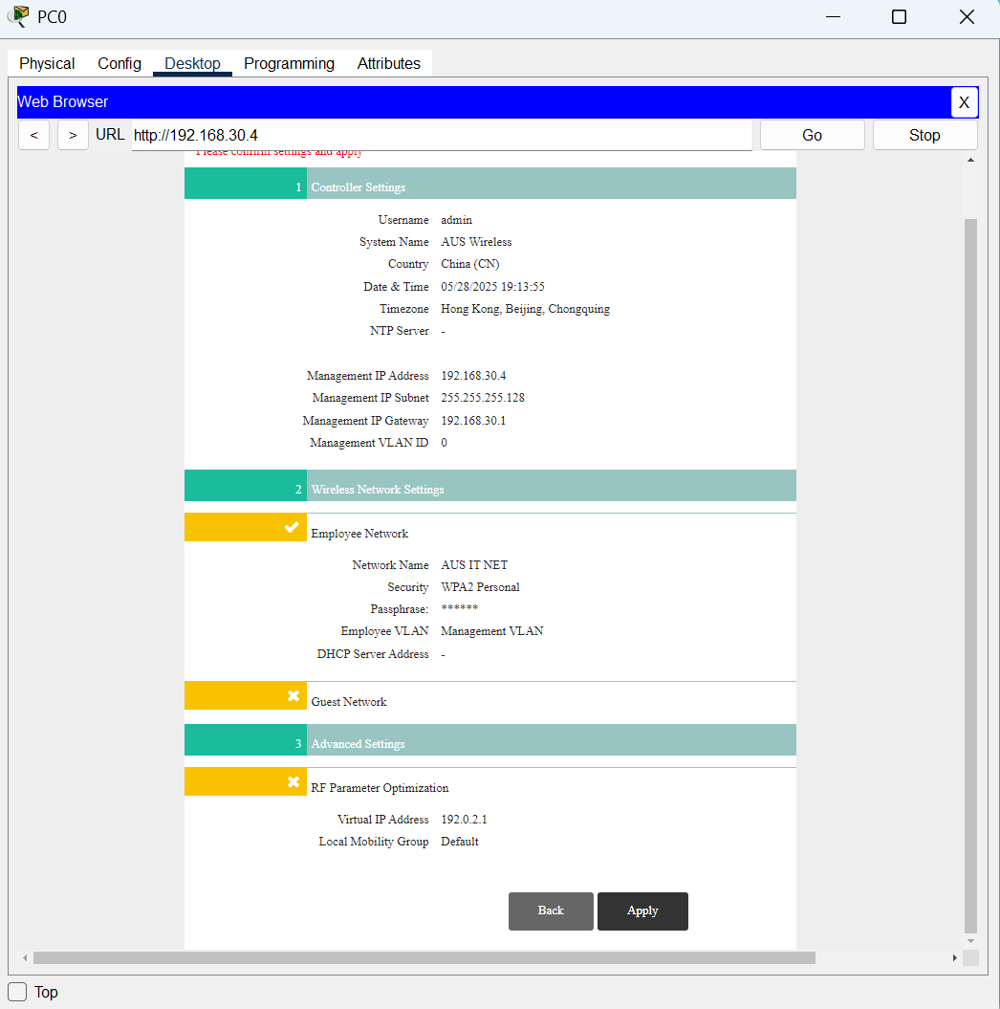

WLAN Architecture 9

Next, re-enter the URL with https://(IP of the WLC Controller) and type in the username and password to login into the WLC Controller.

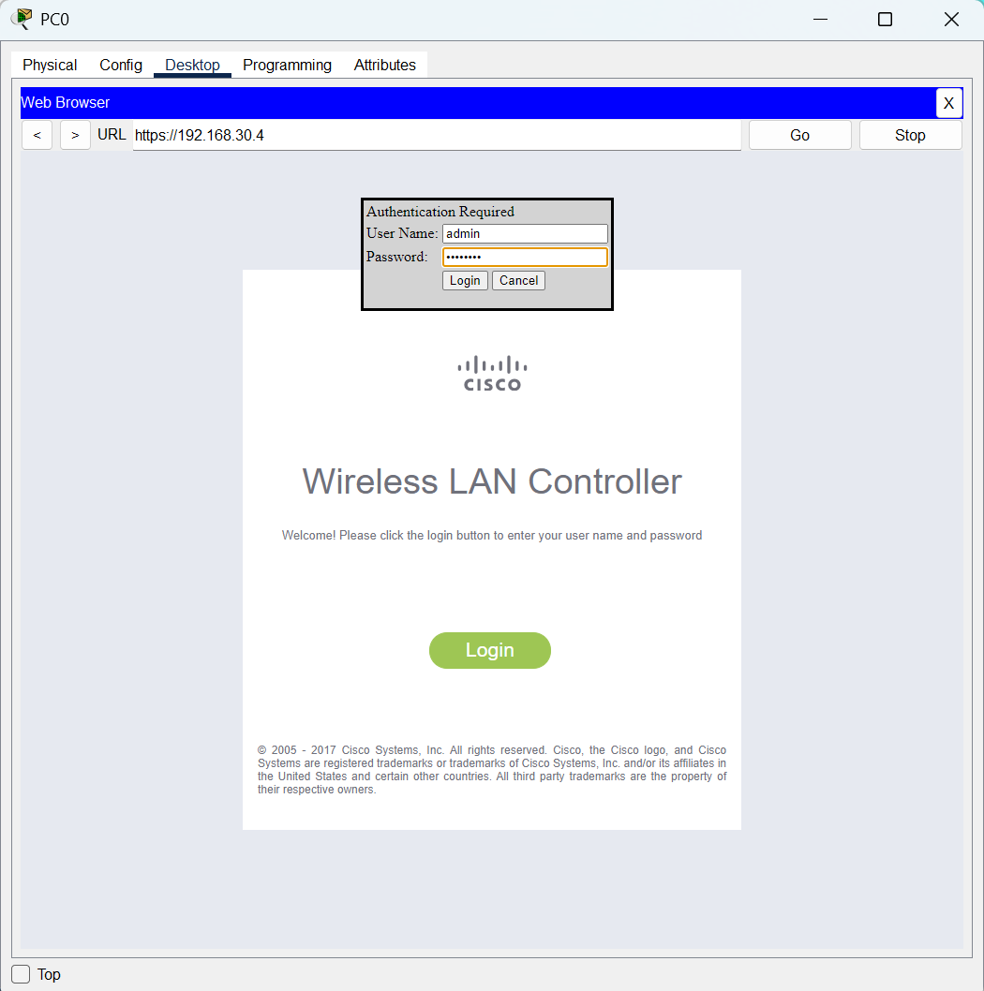

WLAN Architecture 10

If successfully login, it will come to this page. Click on the WLANs to go to the next page.

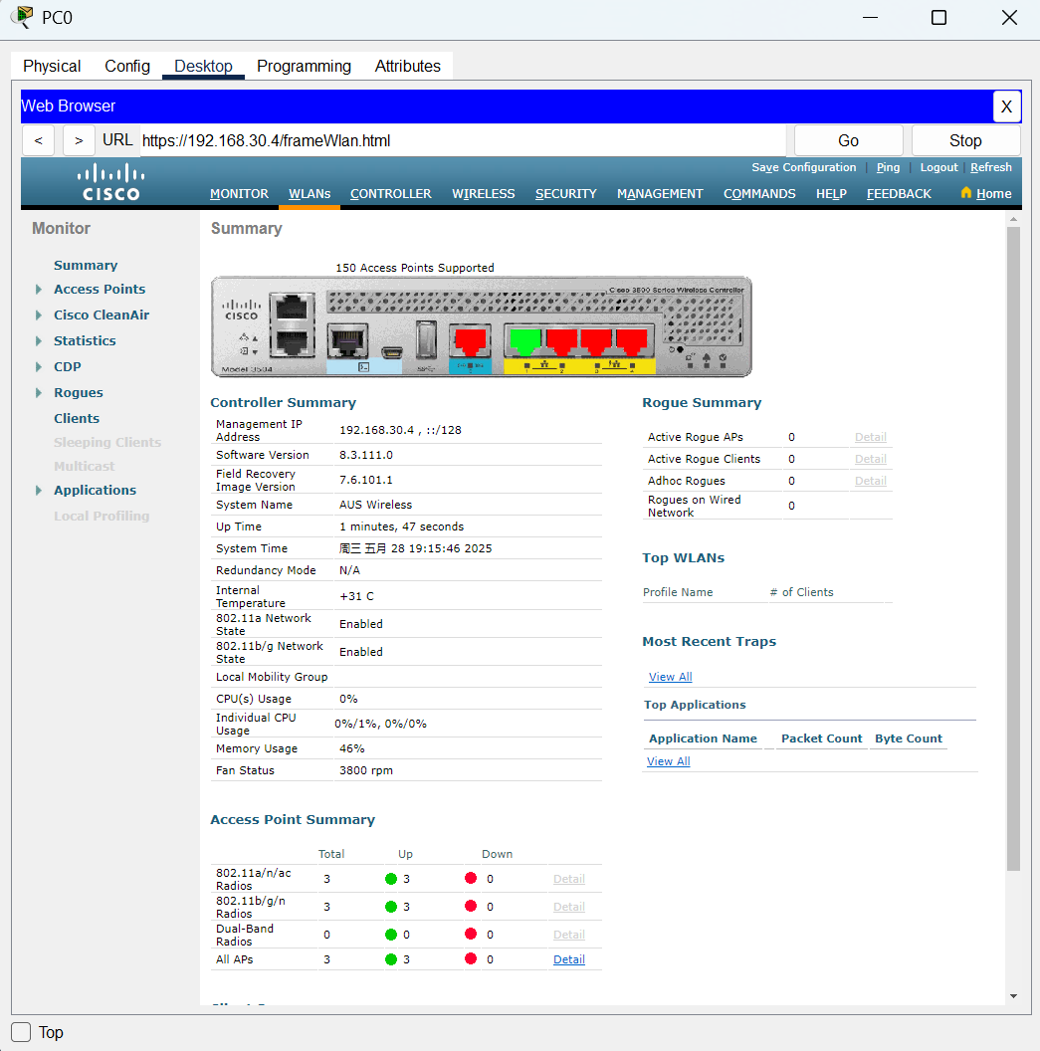

WLAN Architecture 11

And right here it will show the WLANs that just created, click on the Go button to create a new WLAN.

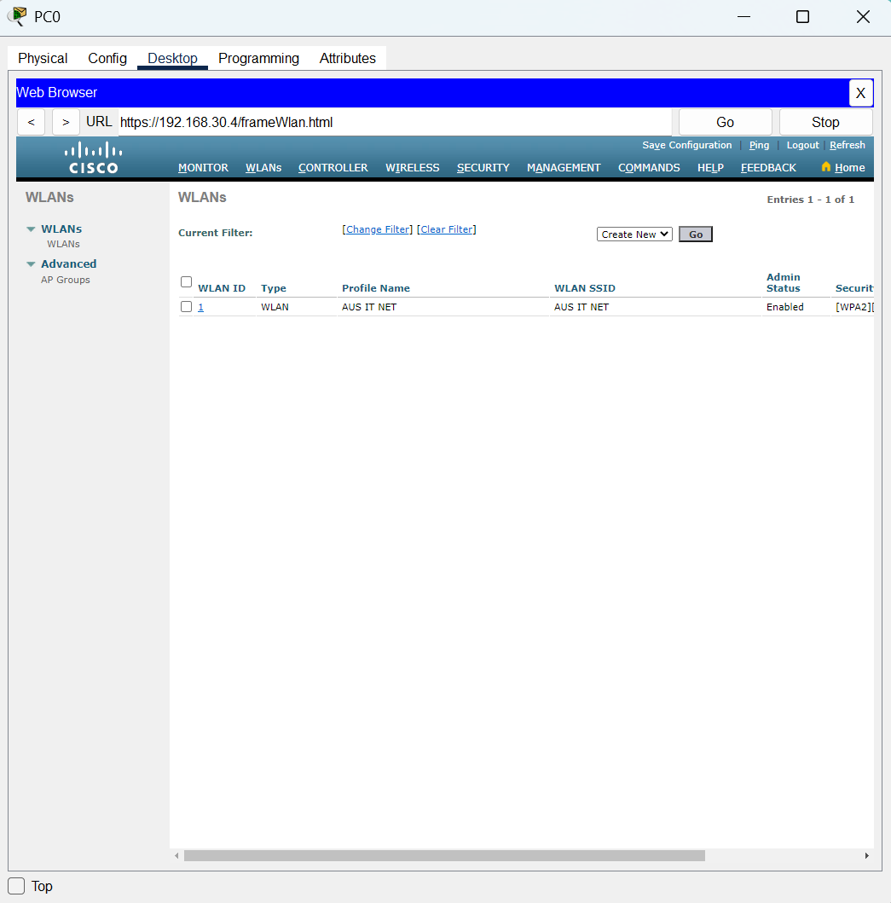

WLAN Architecture 12

Next, enter a new Profile name for the WLAN and the SSID can be the same name and next click on the Apply button.

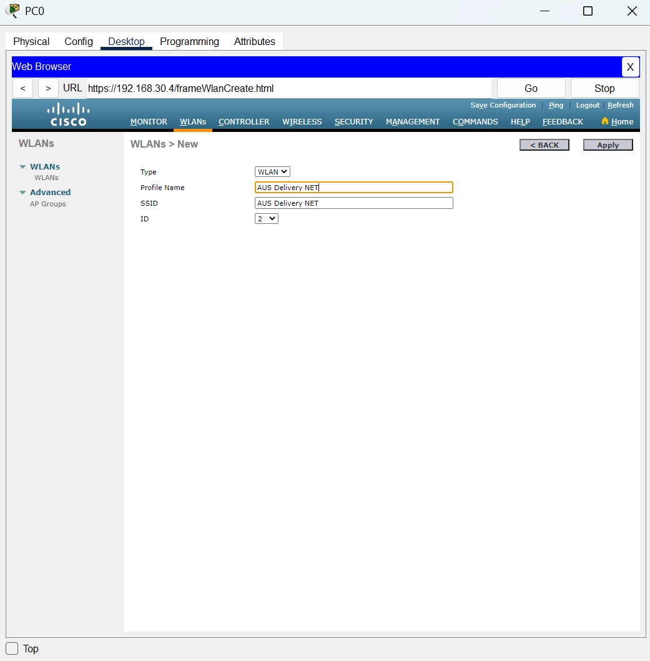

WLAN Architecture 13

It will lead to the General page of the WLAN just created and to enable the status click on the check box to enable it. Then, click on the Security beside the General.

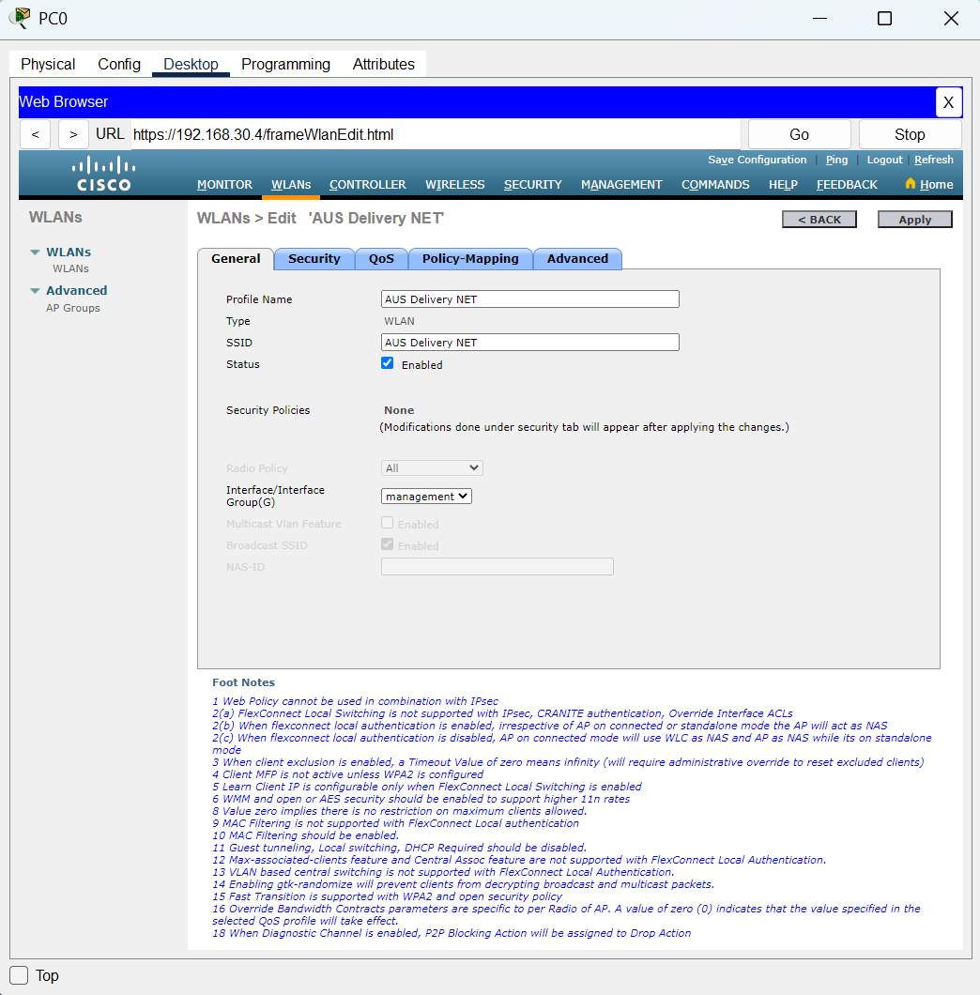

WLAN Architecture 14

At the Security page we choose the WPA + WPA2 at the layer 2 security.

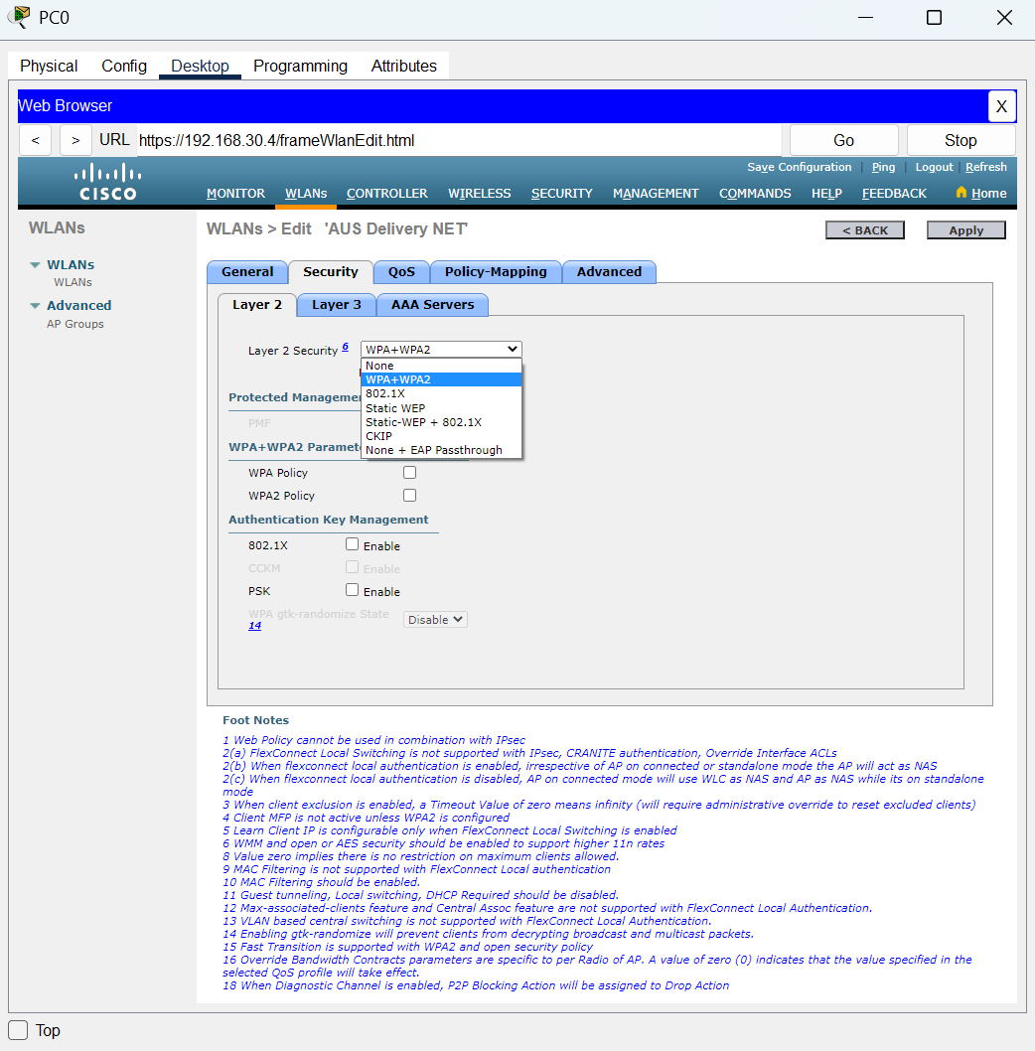

WLAN Architecture 15

Then, click on the WPA2 Policy checkbox and the enable the PSK.

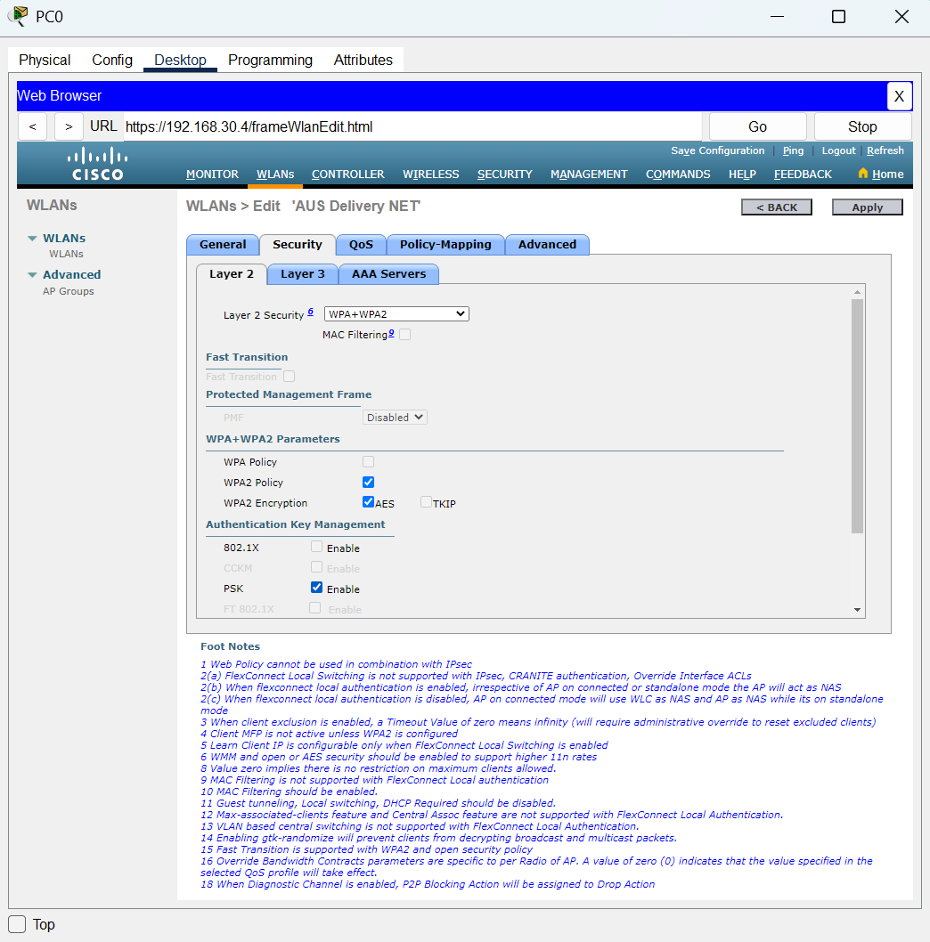

WLAN Architecture 16

Last, enter the password at the textbox and then click on the Apply button to apply the new WLAN.

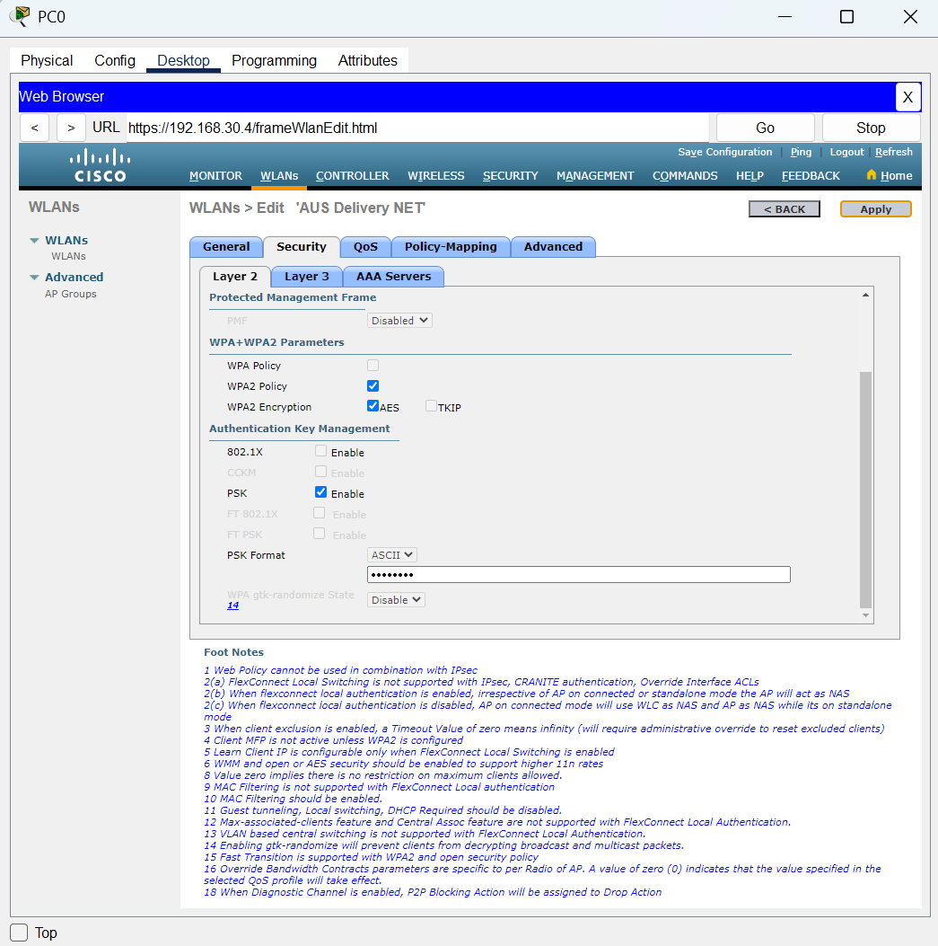

WLAN Architecture 17

These are the WLANs that created. Next, click on the AP Groups to apply the group for the WLANs.

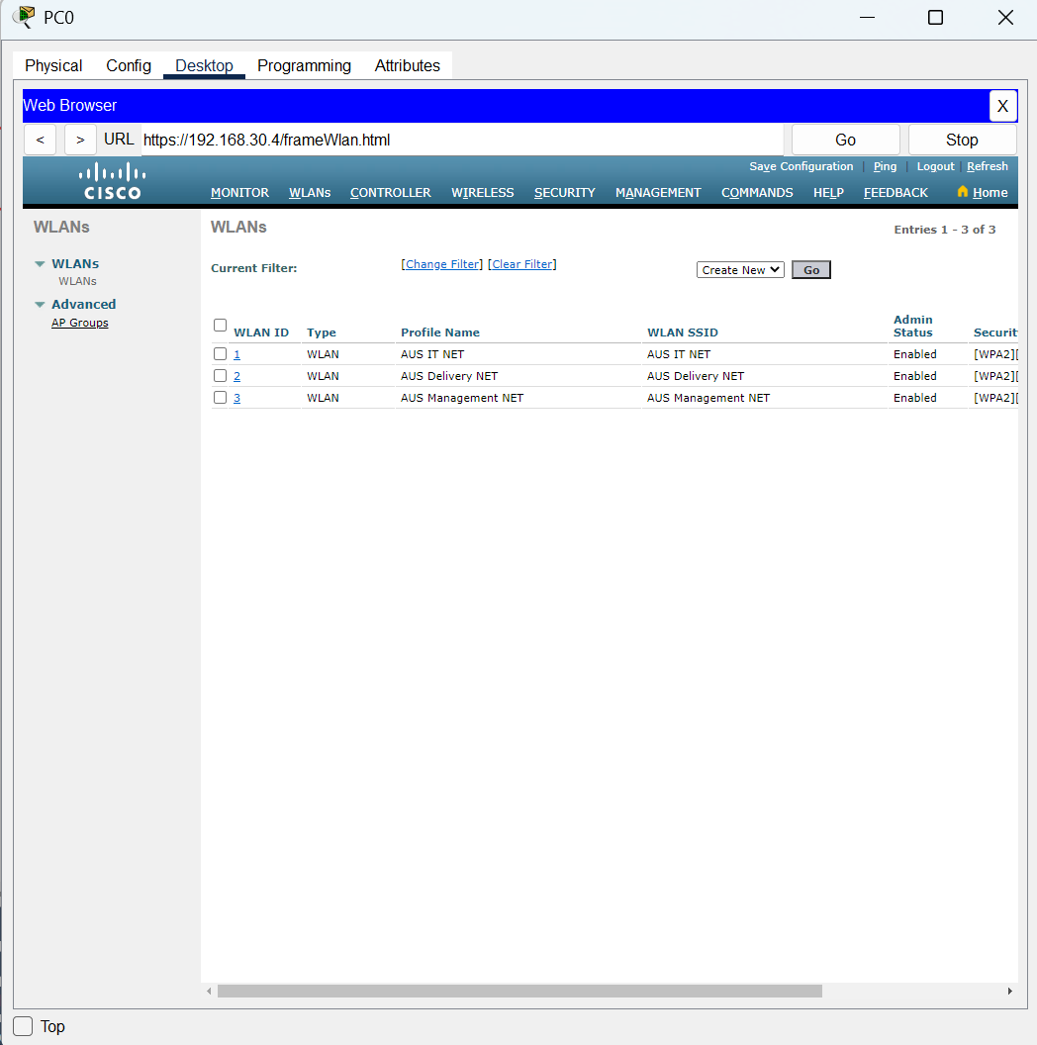

WLAN Architecture 18

Click on the Add Group button and then type in the group name and the description of the group. And then click on the Add button to add it.

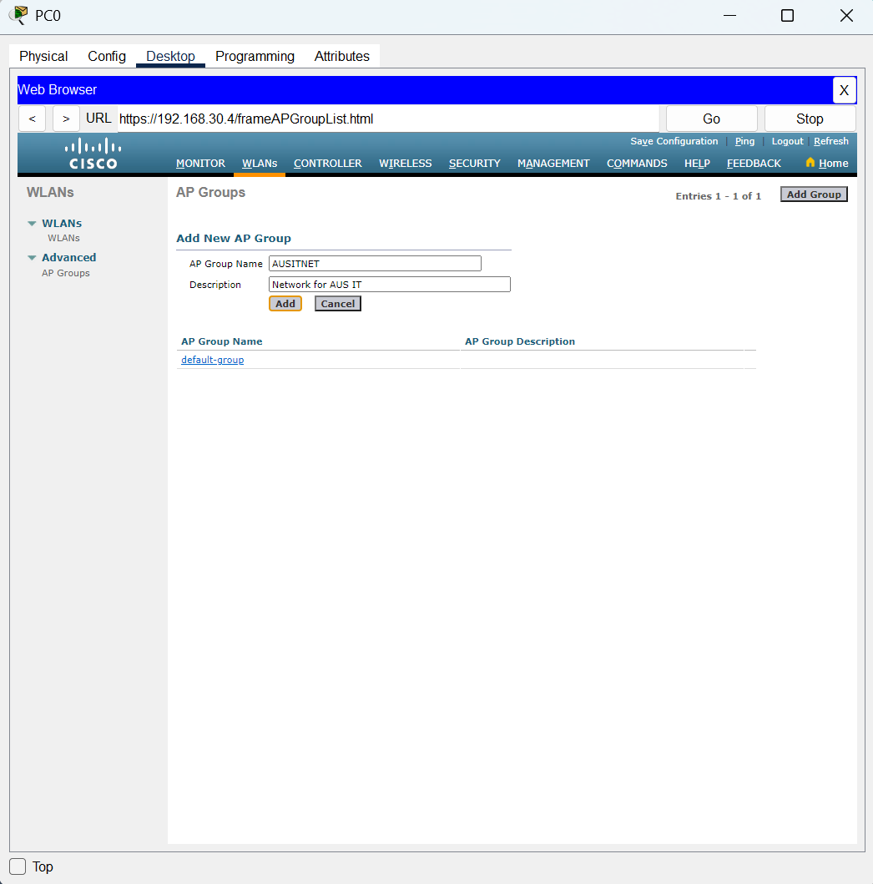

WLAN Architecture 19

Next, click on the Group name.

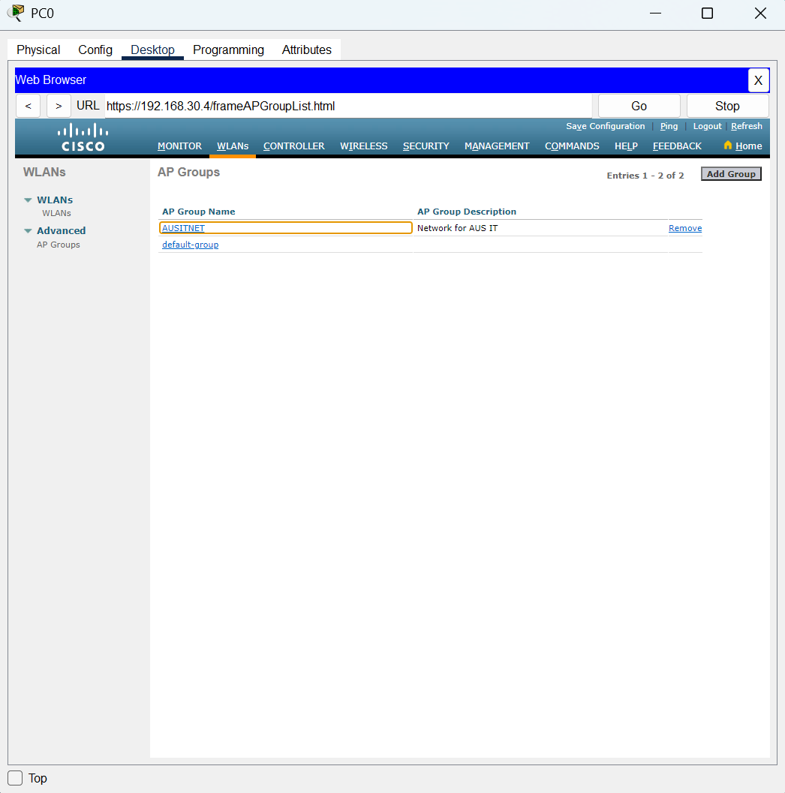

WLAN Architecture 20

Click on the WLANs which is beside the General page, next click on the Add New button then chooses the correct WLANs SSID for the group of IT Department. Last, click on the Add button to add it.

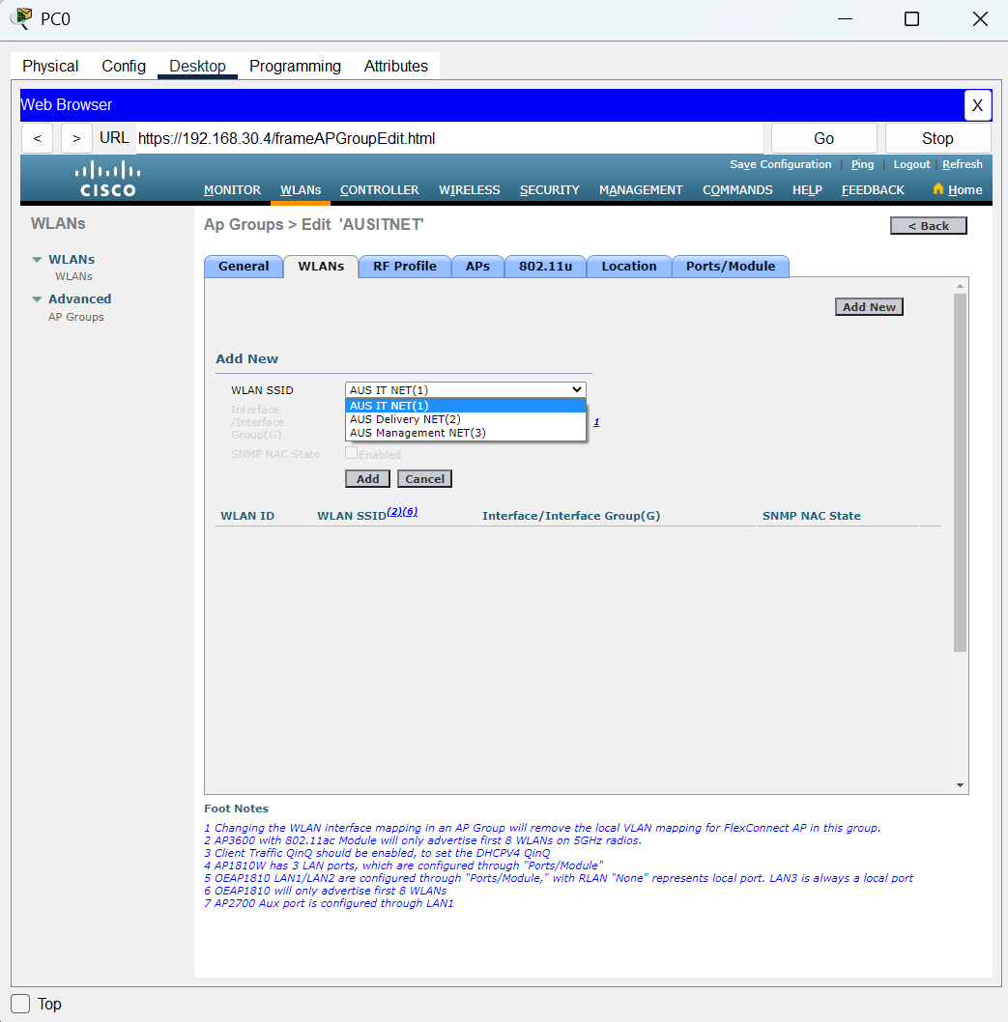

WLAN Architecture 21

Next, click on the APs to choose the correct access point for the group. Then, click ok to confirm it.

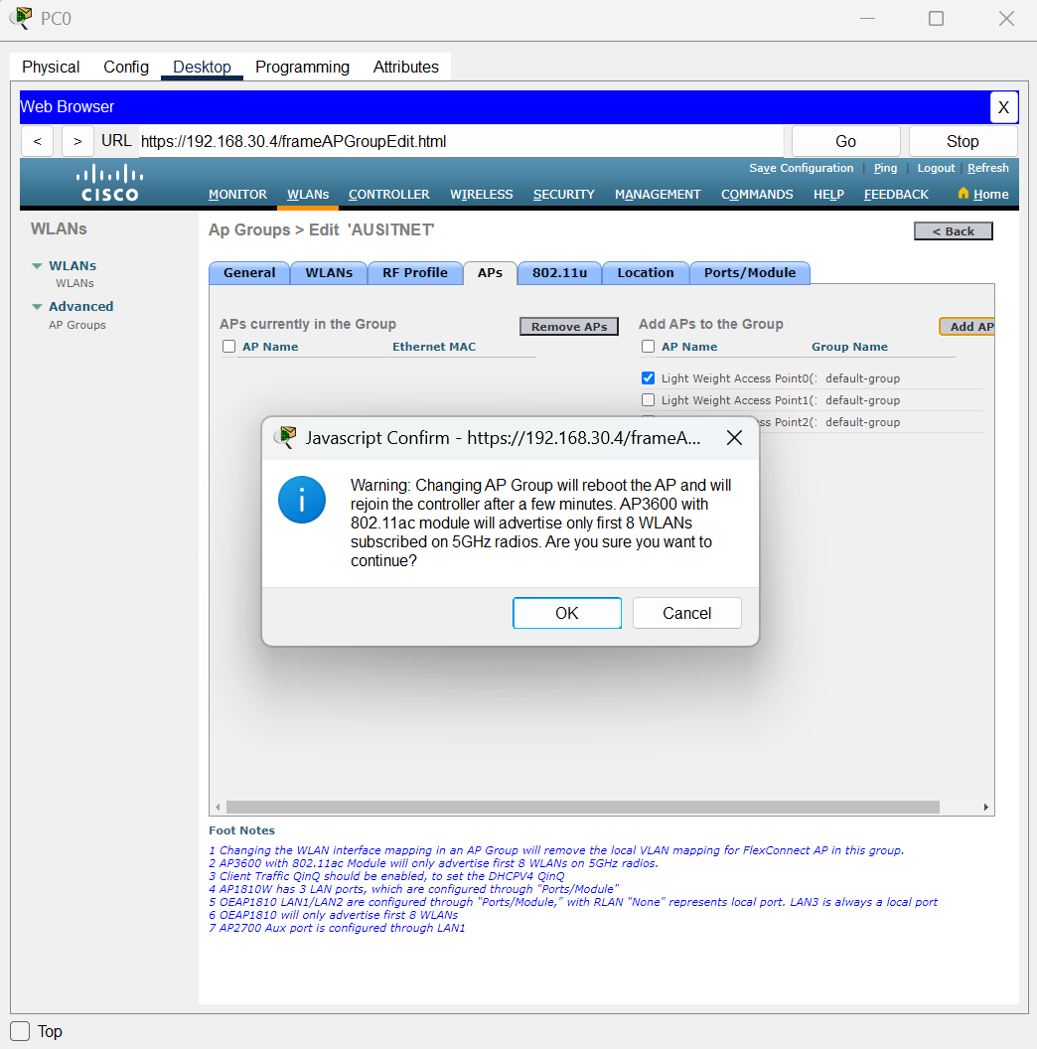

WLAN Architecture 22

After completing the edit at group, click on the CONTROLLER and then click on the Interfaces at the left side of the Controller Menu.

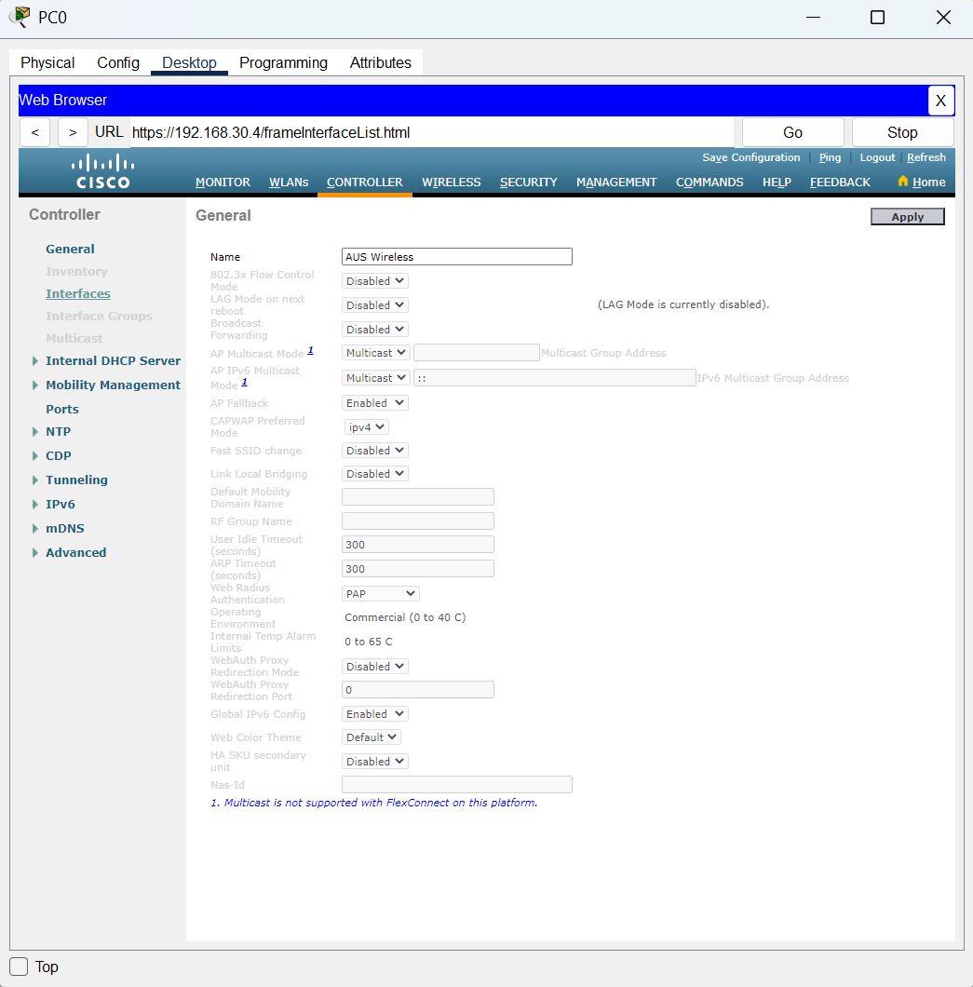

WLAN Architecture 23

Right here, scroll to the right until the end the New button will comes out. Next, click on the New button to create the new interfaces for the VLAN 40 and VLAN 50.

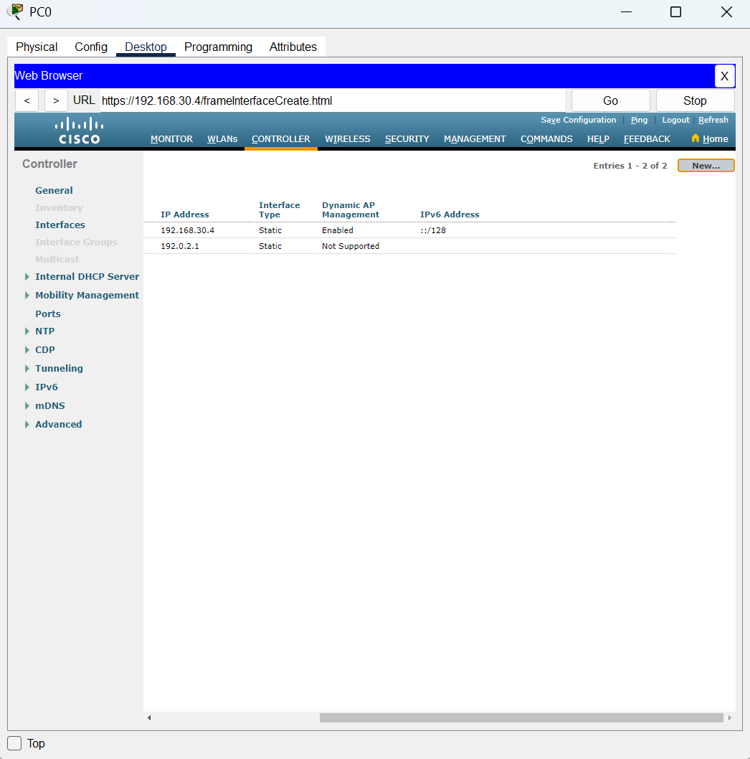

WLAN Architecture 24

Type in the name of the interface and the VLAN Id and then click on the Apply button.

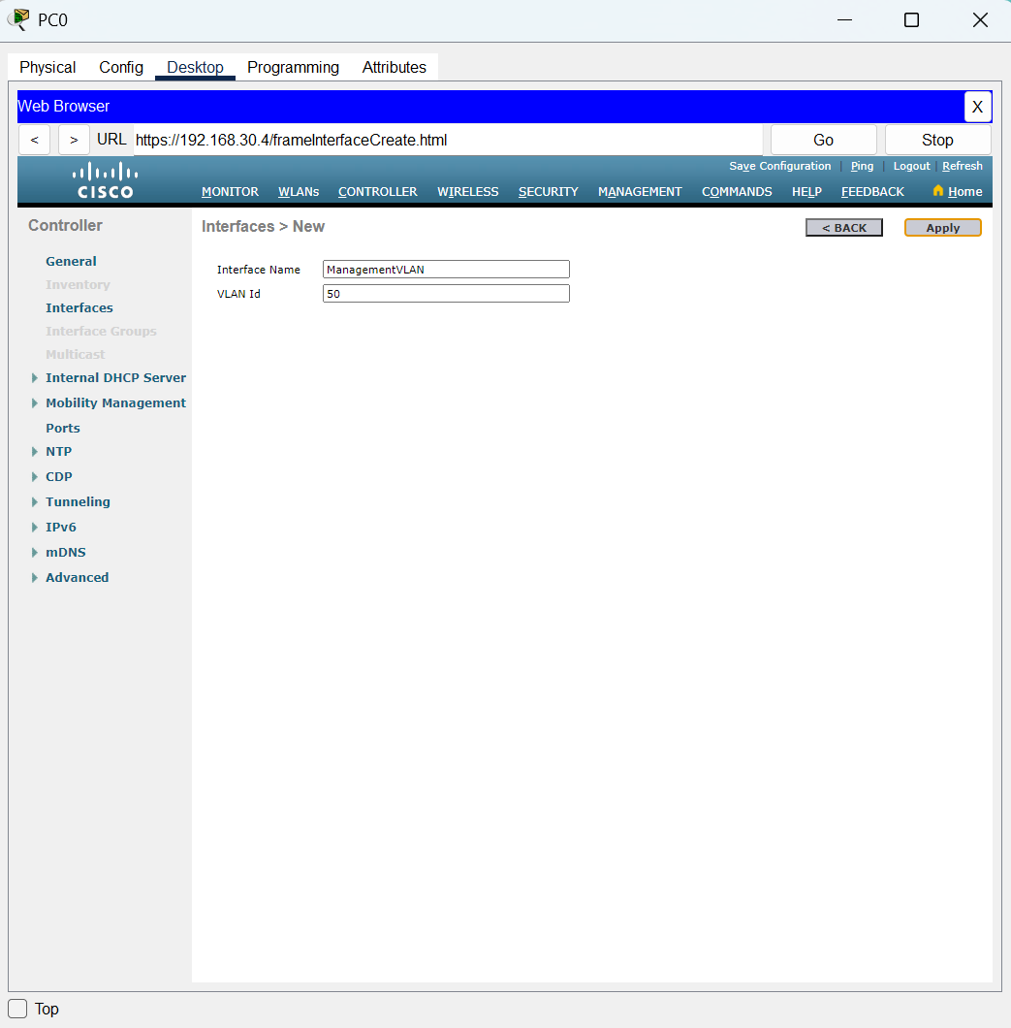

WLAN Architecture 25

Next, setting the port number to 1, the VLAN identifier is 50, IP address is 192.168.50.1, subnet mask is 255.255.255.192, Gateway is 192.168.50.1, and in the DHCP Server enter the IP of 192.168.30.3 then click on the apply to apply the setting.

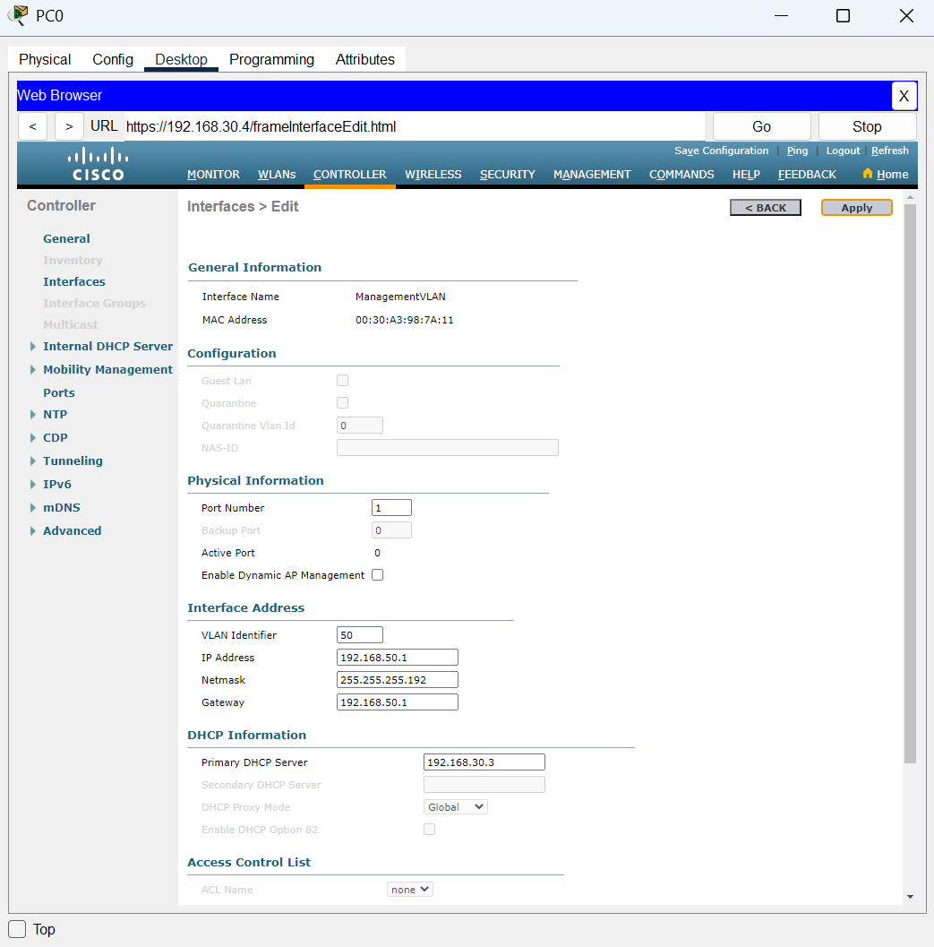

WLAN Architecture 26

A confirm message will pop out that can just click on the OK button to proceed it.

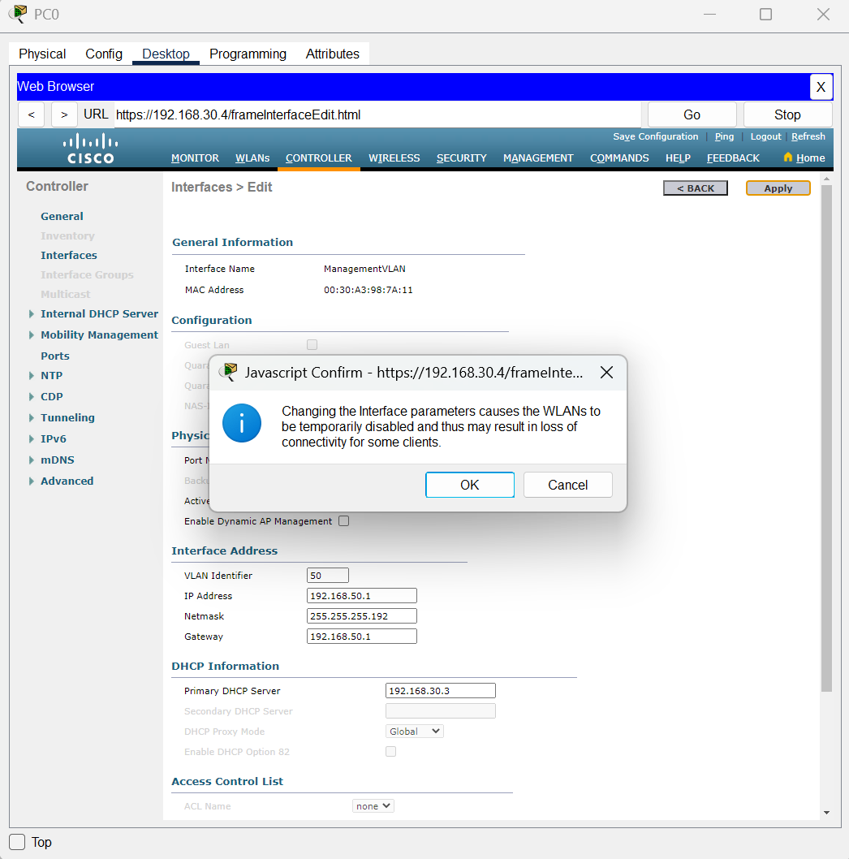

WLAN Architecture 27

Next, go back to the WLANs and click on the WLANs that need to change the interface which is the AUS Delivery NET and the AUS Management NET. And then click on apply after changing the interface.

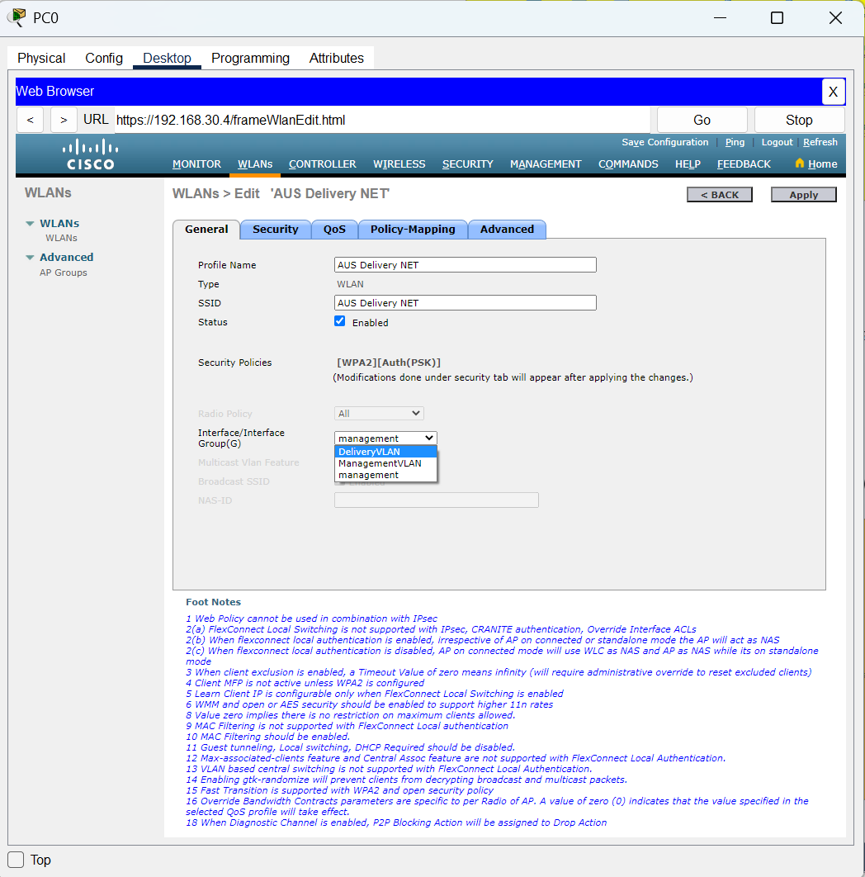

WLAN Architecture 28

Right here the WLANs configuration is successfully.

1. EtherChannel Implementation

**KLS1**

This is the EtherChannel Configuration of KLS1 (KL Management). Channel-group 1 is the group which connecting with KLS2. The interfaces switchport mode also have change to trunk mode.

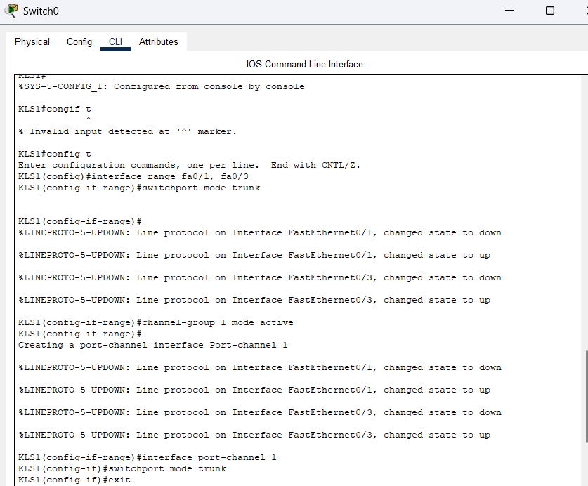

EtherChannel Config 1

Channel-group 2 are connecting with KLS3.

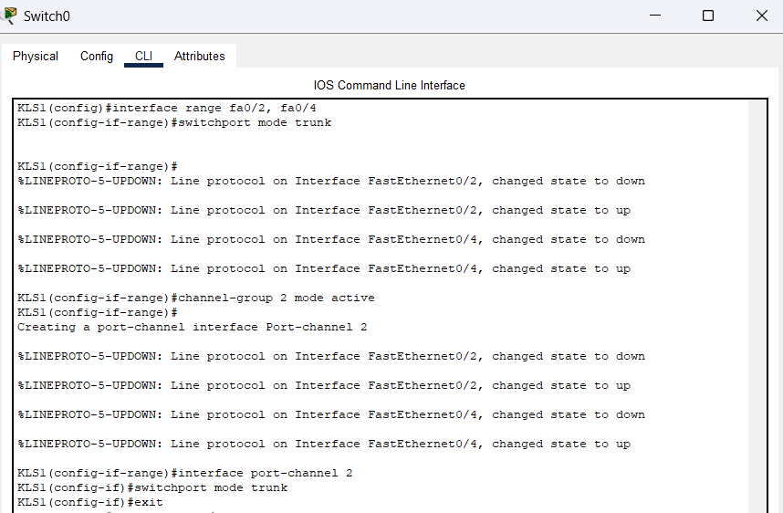

EtherChannel Config 2

These interfaces are connecting with KLR1 and KLR2, both of the switchport mode also changed to trunk mode.

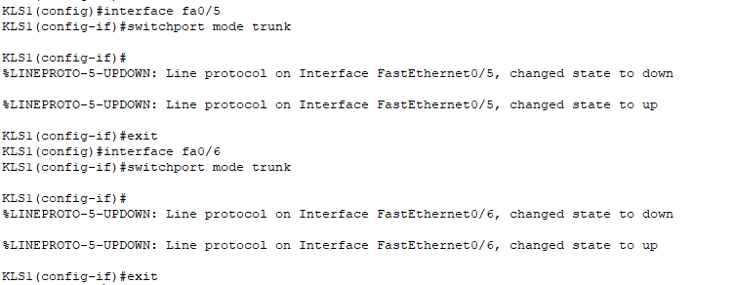

EtherChannel Config 3

**KLS2**

This is the EtherChannel Configuration of the KLS2 (KL Human Resource). These interfaces are connected with KLS1, so it grouped by channel-group 1. And the interfaces and port-channel also need to change the mode to trunk.

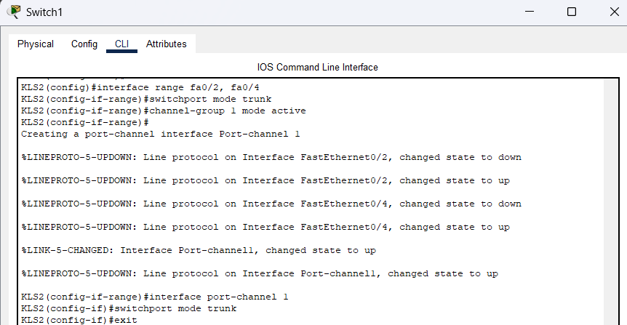

EtherChannel Config 4

These interfaces are connected with KLS3, so it should create a new port-channel, which is port-channel 3, and the switchport mode also need to change to trunk mode.

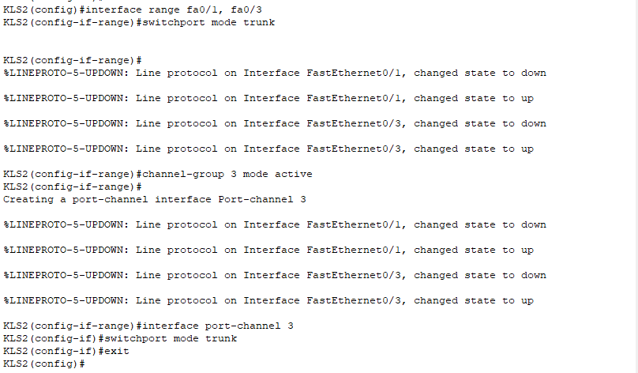

EtherChannel Config 5

**KLS3**

This is the EtherChannel Configuration of the KLS3 (KL Design). These interfaces are connected with KLS1, so it should active the channel-group 2 for EtherChannel. Remember to change the switchport mode of interfaces and channel-group to trunk.

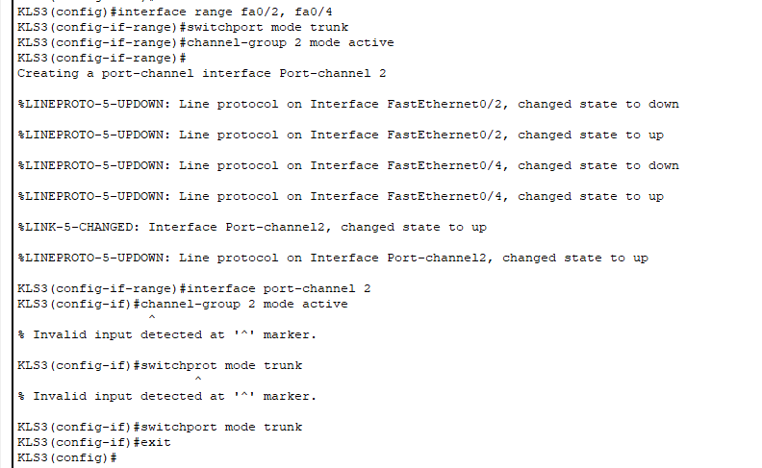

EtherChannel Config 6

These interfaces are connected with KLS2, so active the channel-group 3 is necessary. Change the switchport mode of interfaces and channel-group to trunk.

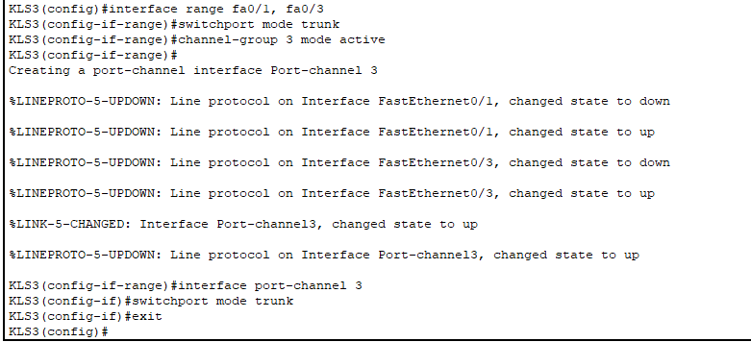

EtherChannel Config 7

1. HSRP Implementation

**KLR1**

This is the HSRP configuration of the KLR1(KL Router 1). This router is the standby router as its priority is lower.



HSRP Config 1



HSRP Config 2

**KLR2**

This is the HSRP Configuration for KLR2, this router is the main router so its priority is higher than KLR1, it can make sure that the router should be in active status.

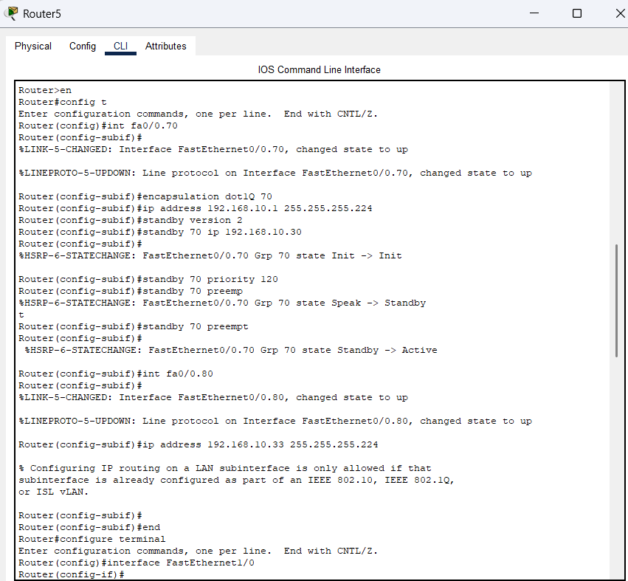

HSRP Config 3

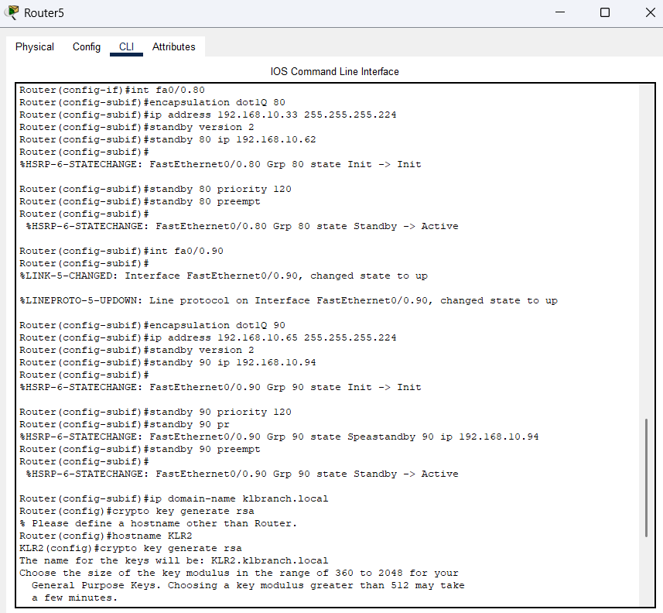

HSRP Config 4

1. Configure Server Service in Server Farm

**Singapore Branch**

**Switch 1**

This is the configuration of SG branch switch 1(server switch)

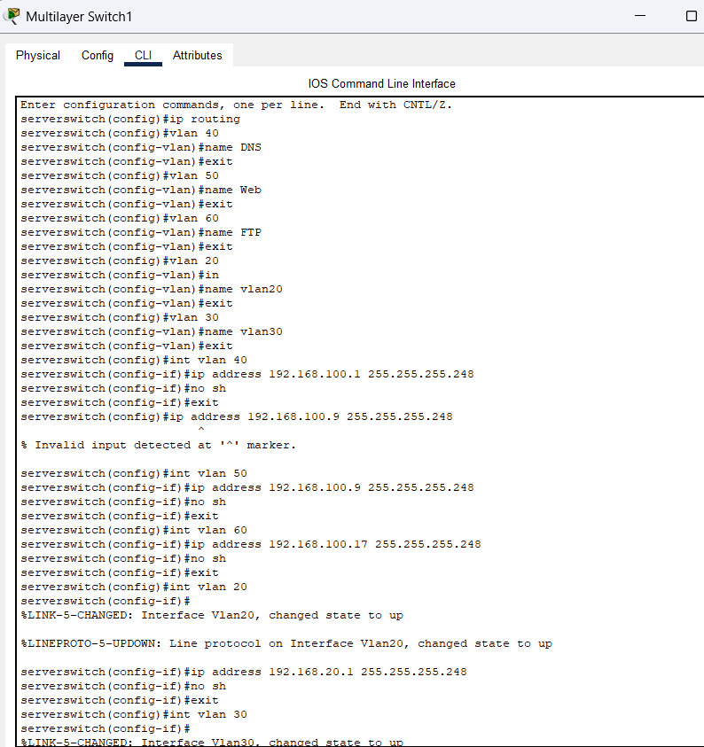

Server Farm Config 1

Configure VLANs and sub-interfaces, name them and then configure the VLAN interface IP.

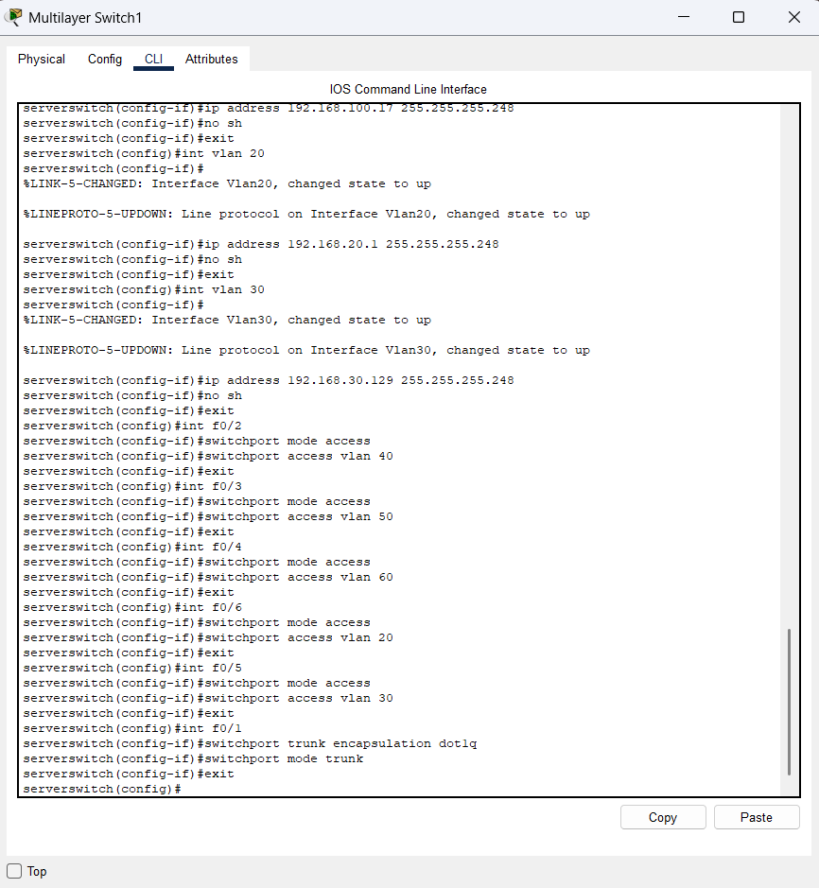

Set the Access interface to each VLAN

Server Farm Config 2

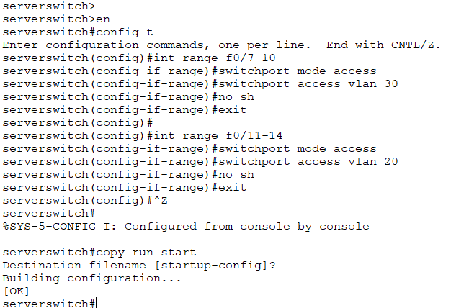

Server Farm Config 3

Set Access interface to each VLAN and Trunk to switch 1 (server switch).

Router0

This is the configuration of SG branch router 0 (routers).

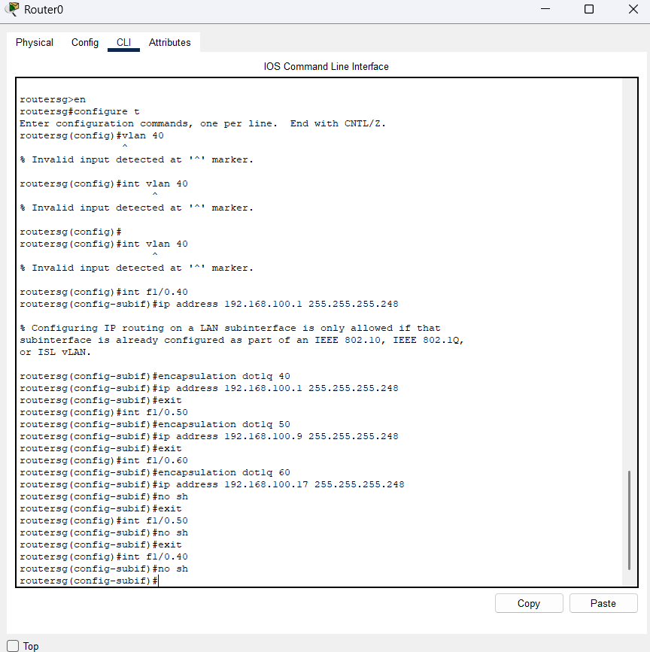

Server Farm Config 4

Specify the SVI interface for each VLAN.

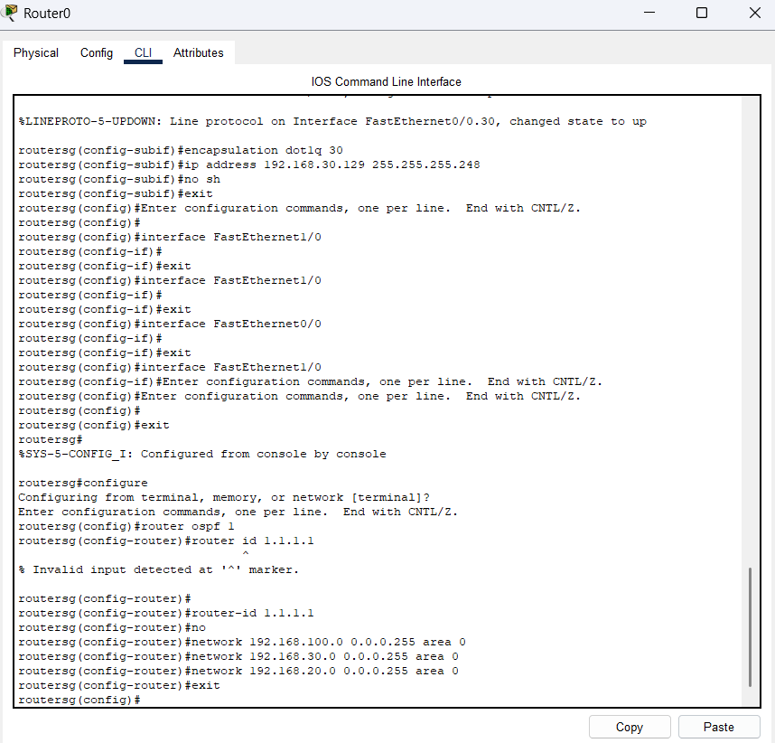

Server Farm Config 5

The sub-interface of vlan30 is created and configured with IP address.

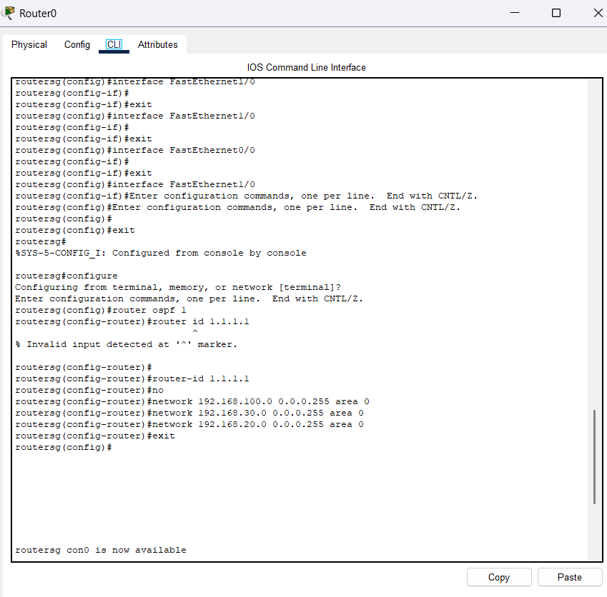

Server Farm Config 6

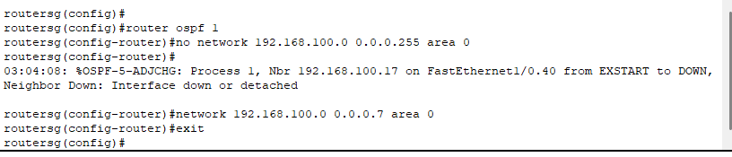

Server Farm Config 7

Configuring the OSPF routing protocol in the router 0 (routers).

And this is the IP route and the OSPF which has already configured in the Router 0 (routers)

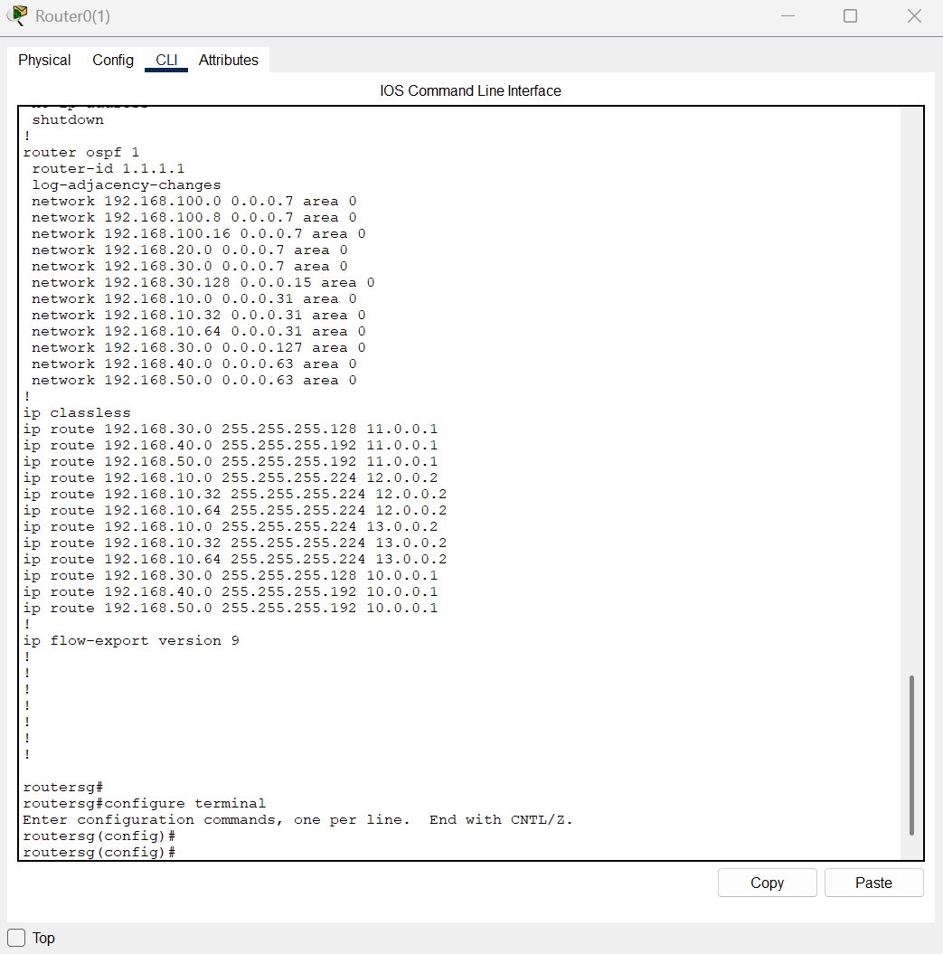

Server Farm Config 8

This configuration can allow the pc in Singapore ping to the Australia or KL branch pc.

1. Ping commands to proof that the network are interconnected

**Australia Branch**

The Laptop0 in the IT Department is allowed to ping the AUS S0 in the Australia branch which mean the WAN is working successfully with the correct configuration.

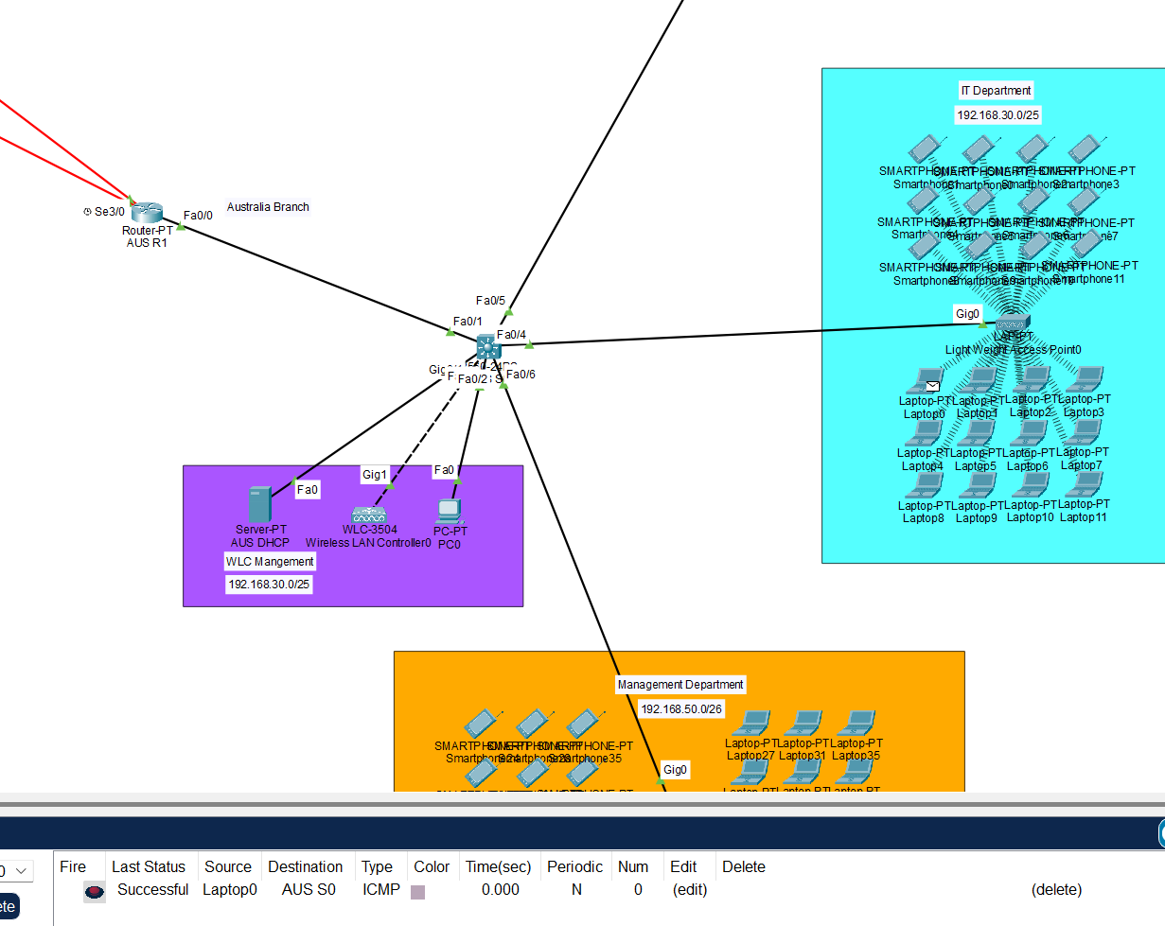

Proof 1

Next, try to ping the difference department in the Australia branch.

The Laptop0 in the IT Department can successfully ping to the Delivery department which use a difference VLAN in the network which mean that the IP routing is working in the network so that it can allow the laptop0 ping to the Lightweight Access Point 1 in Delivery department.

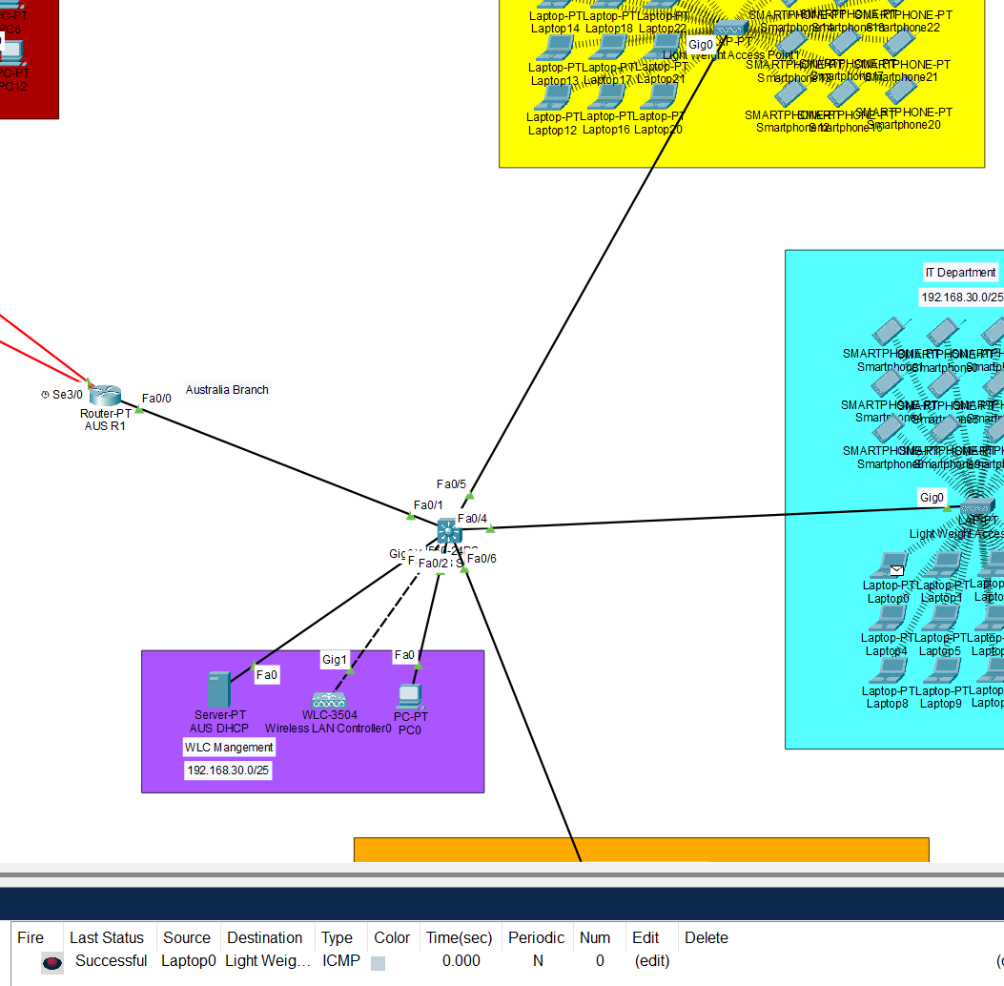

Proof 2

Then the Laptop0 can also ping to the AUSR1 successfully.

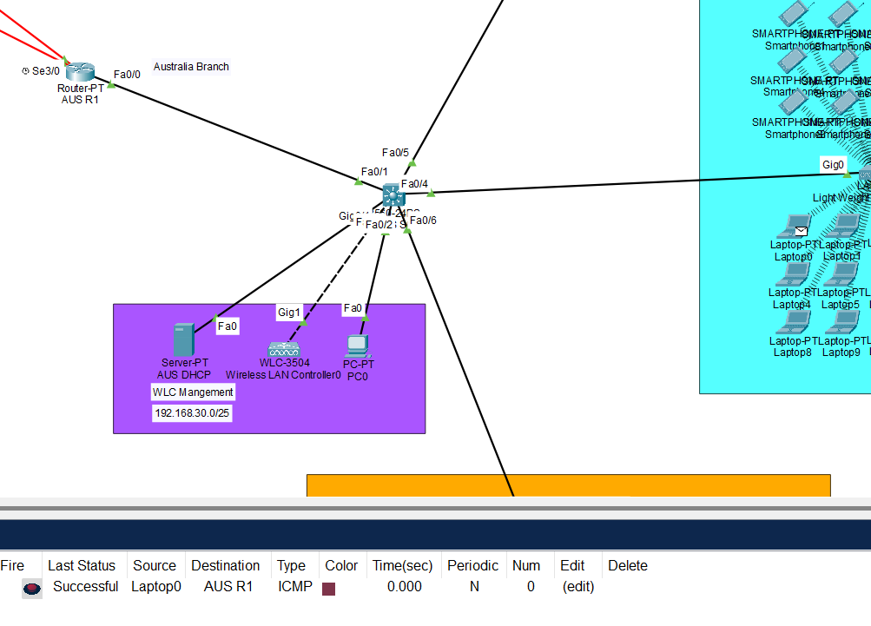

Proof 3

As the network in the Australia branch can work successfully, try to ping to the another branch to see it is interconnected or not.

Then is pinging the laptop to the Singapore branch and KL branch.

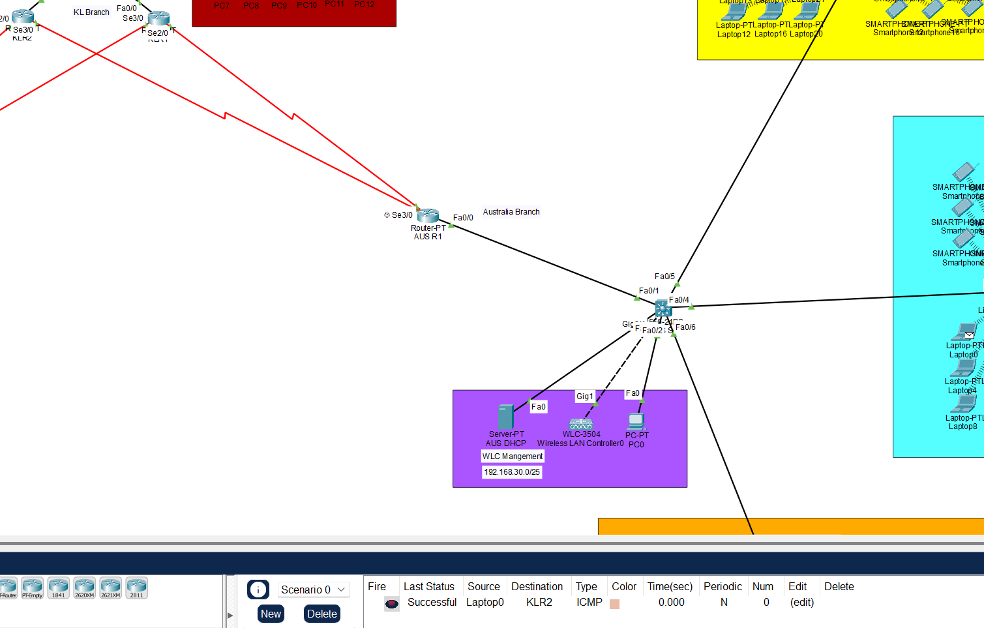

Proof 4

The Laptop0 in the IT Department can successfully ping to the KLR2.

Next is ping to the Singapore branch.

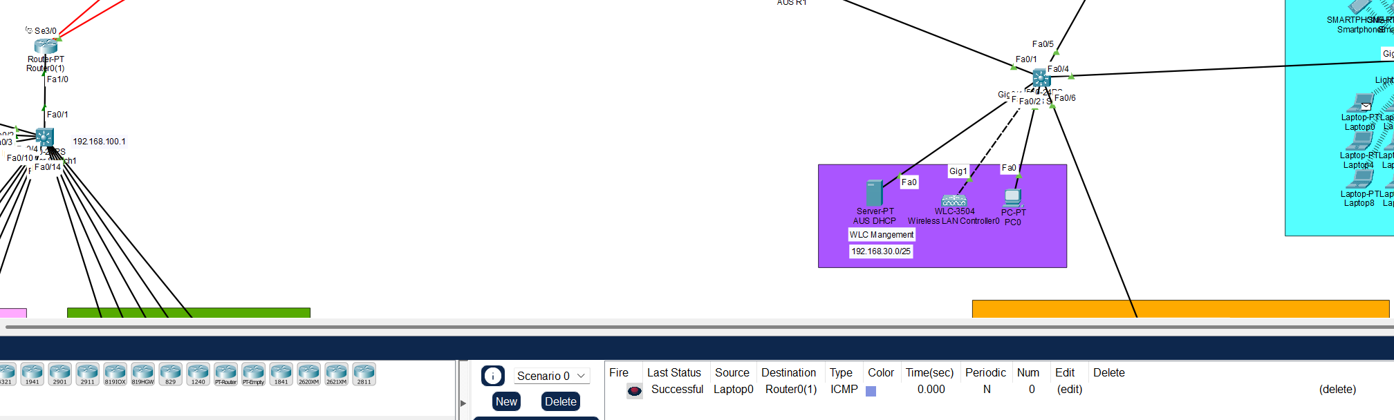

Proof 5

And the Laptop0 in the IT Department can successfully ping to the Singapore branch.

**Singapore Branch**

The SGPC can ping to the DNS Server gateway successfully.

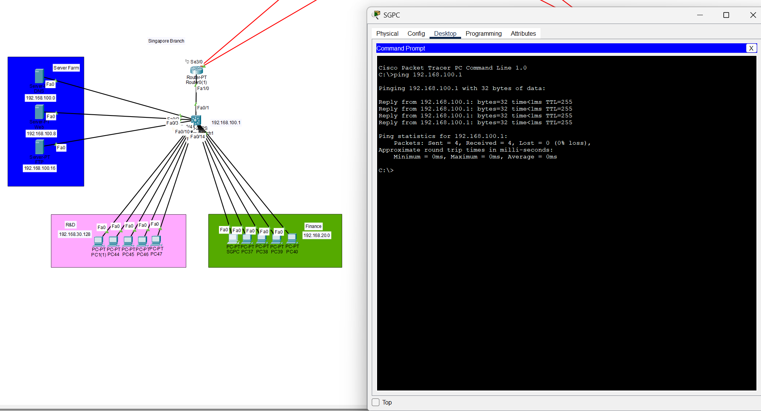

Proof 6

The SGPC in the Finance Department can also ping to the PC1(1) in the R&D Department.

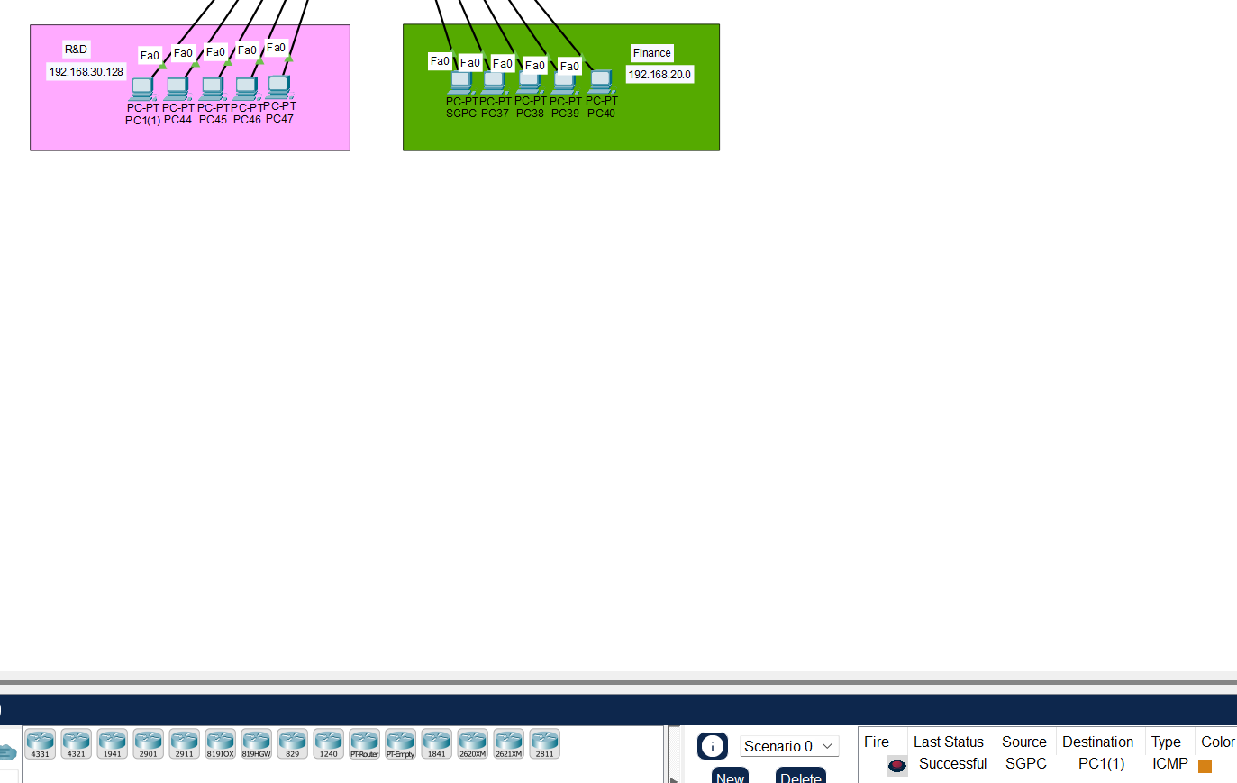

Proof 7

And the SGPC can also ping to the AUSR1(Australia Router 1) which mean the SGPC can send the message successfully to the Australia branch.

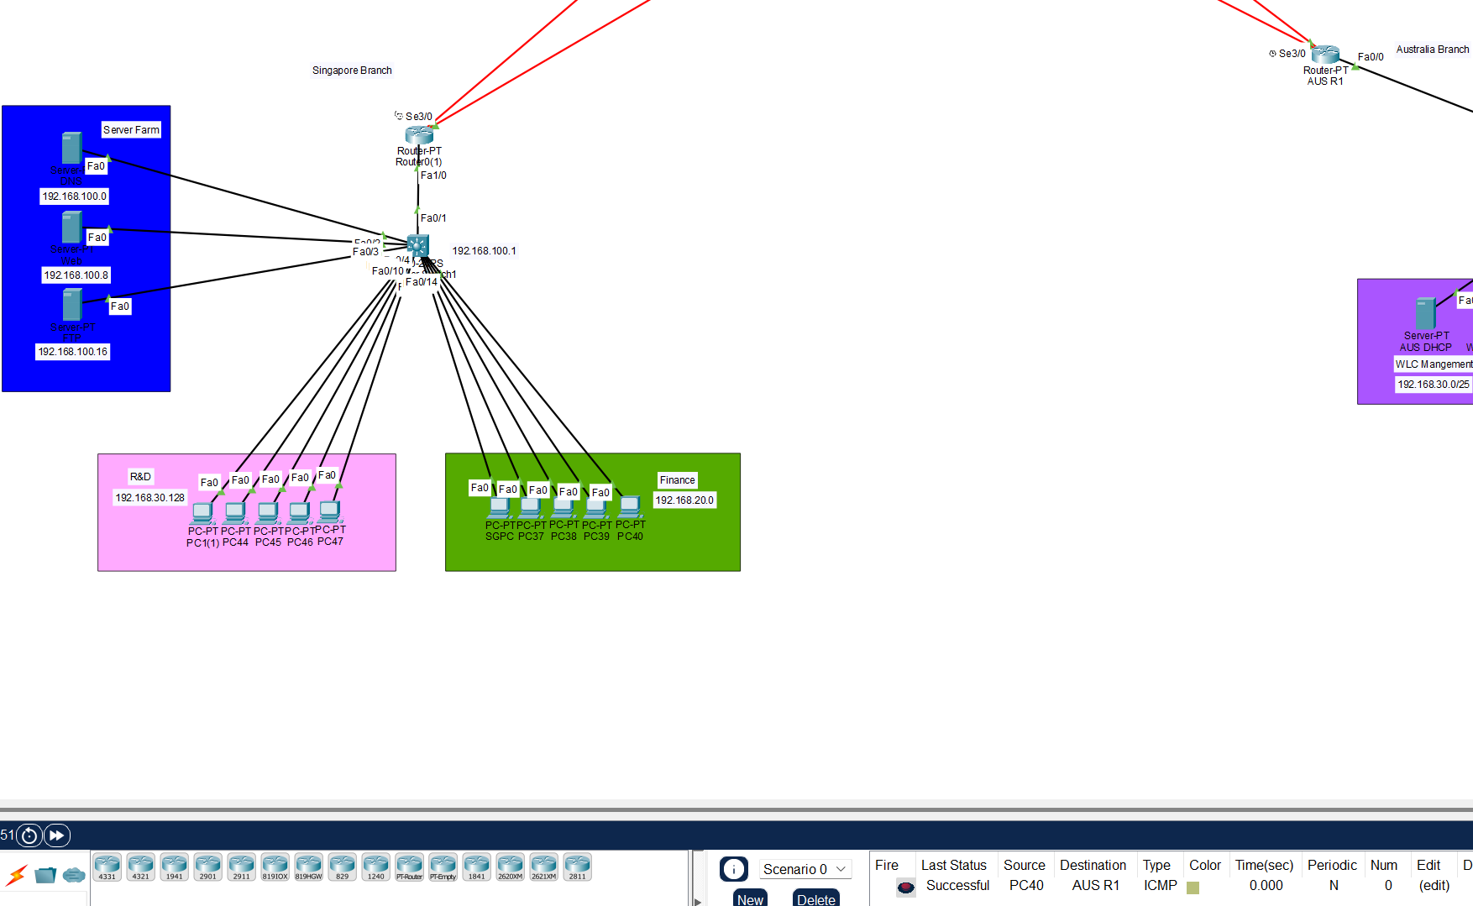

Proof 8

The SGPC can also ping to the KLR2 which has already implemented the HSRP. So, the SGPC cannot ping to the KLR1.

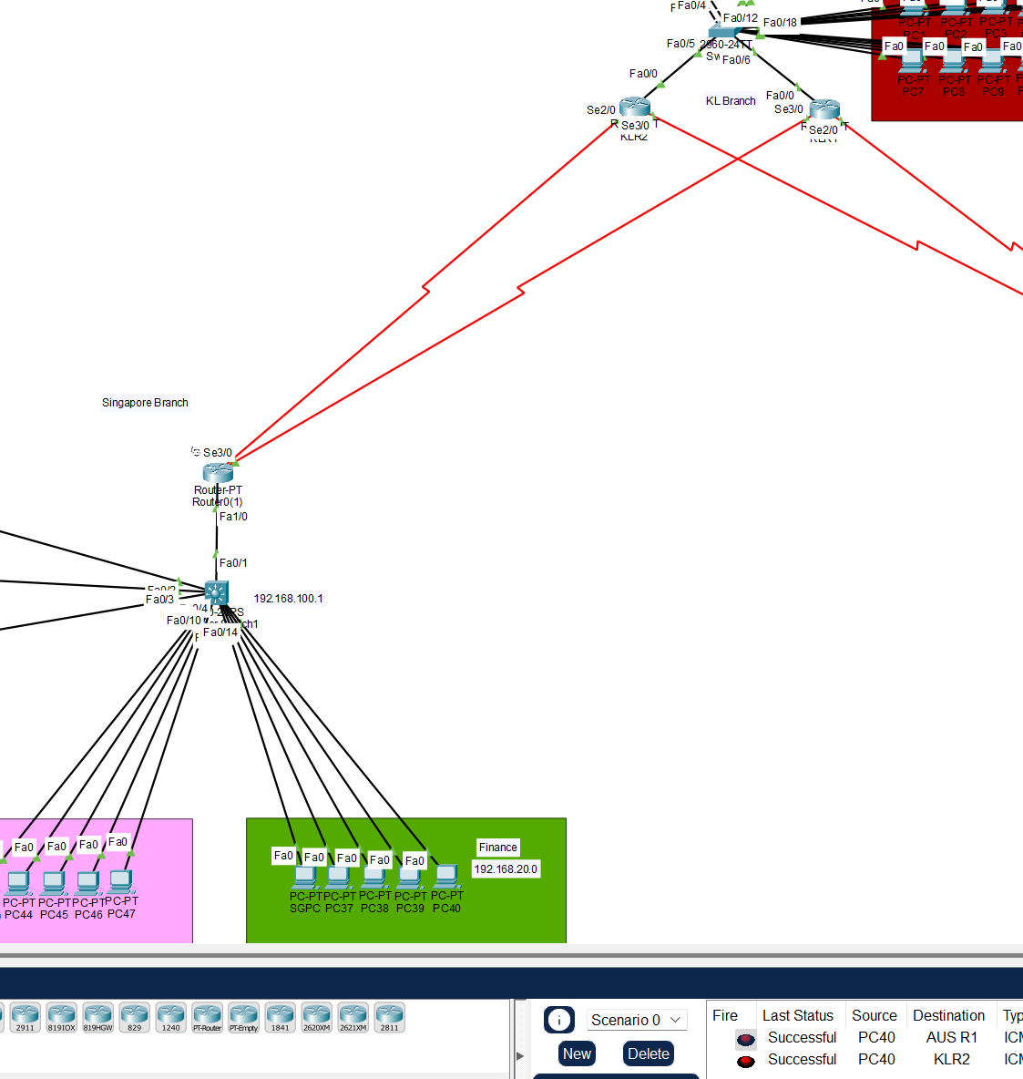

Proof 9

**KL Branch**

The PC7 in the KL Management department can successfully ping to the KLR1.

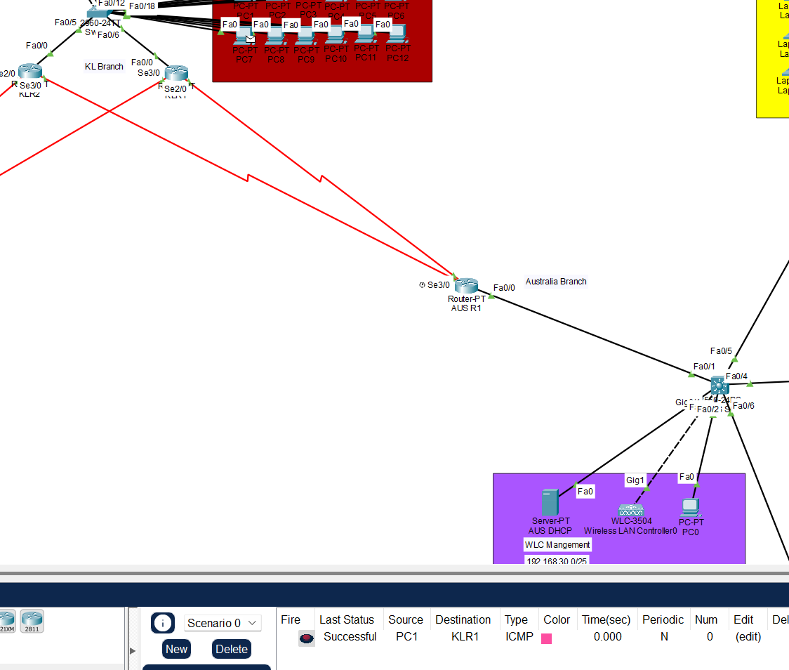

Proof 10

Next, ping the AUSR1 from PC7 which in the Management Department.

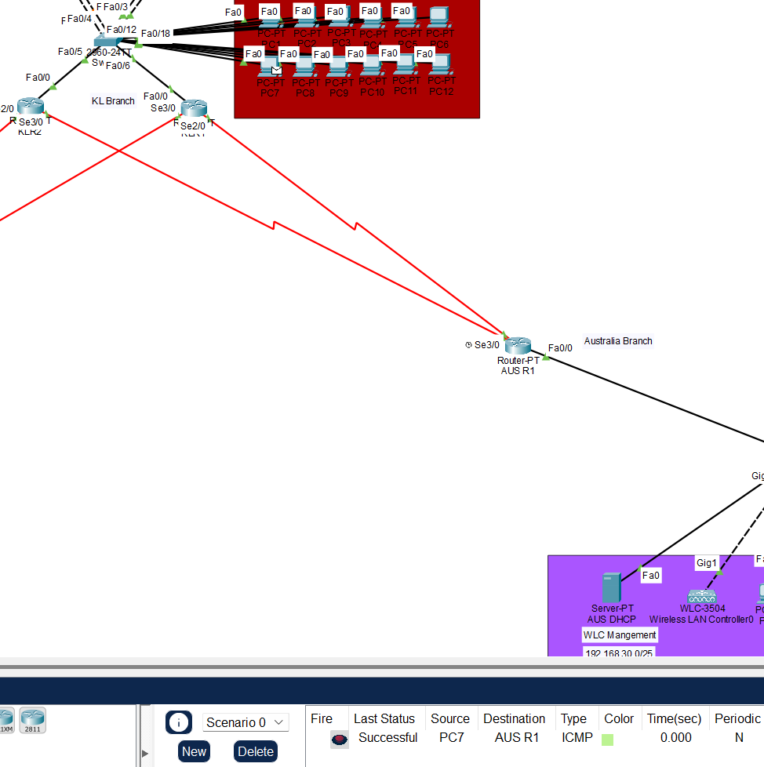

Proof 11

And it can ping successfully.

Last ping the Router at the Singapore branch from the KL Management PC7.

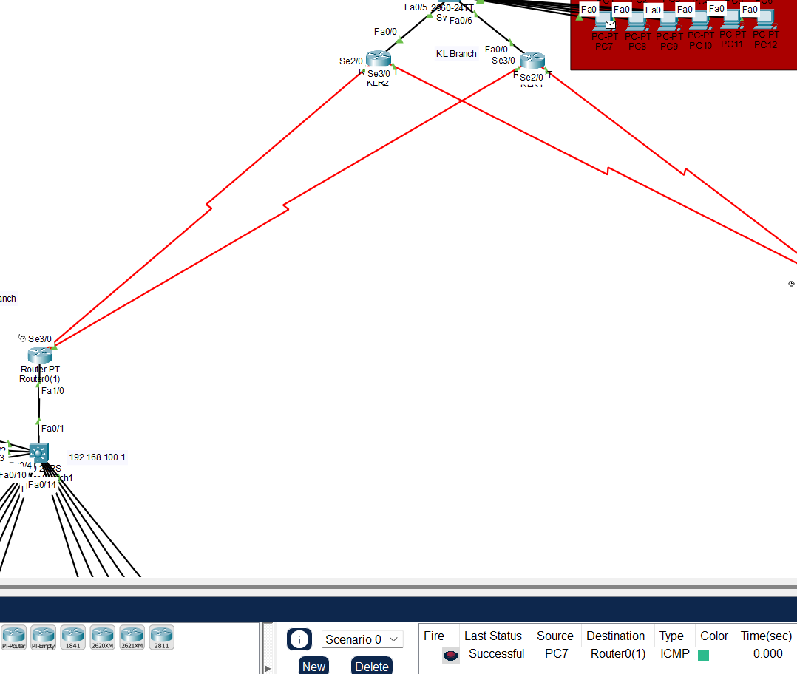

Proof 12

And it shows that it was successful.

**Proof**

As the PC in each branch can ping to each other, which mean that the configuration of the network is correct so that it can allow them to communicate to each other.

1. Basic Security Mechanisms Implementation

**Australia Branch**

Port-security is only implemented in the AUSS0(Australia Switch 0) and the SSH are the basic security mechanisms which has implement in the AUSS0(Australia Switch 0), AUSR1(Australia Router 1), and AUSR2(Australia Router 2).

Port-security Implementation:

Caution: Only the access port should be implementing the port-security, so the interface range is only taken from f0/2-6.

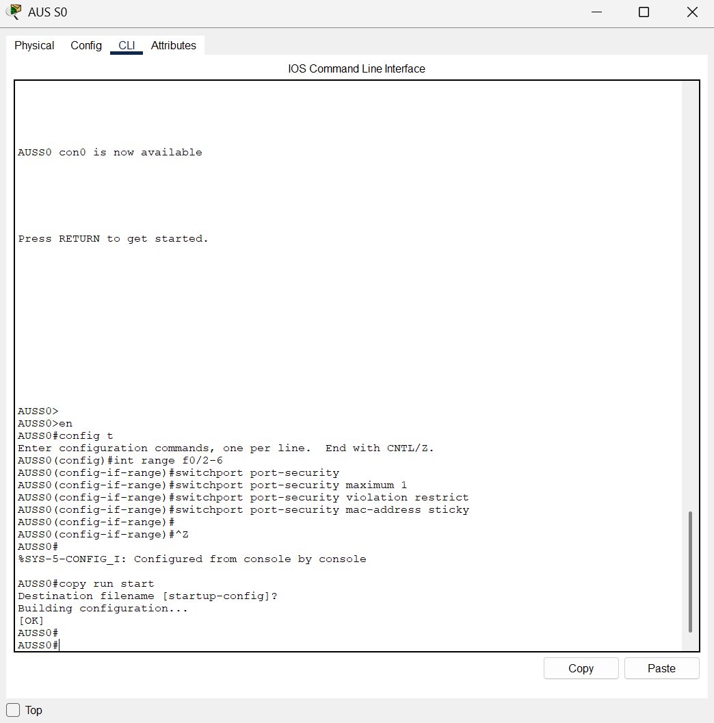

Basic Security Mechanisms 1

The figure proof that the configuration of the port-security is completely implemented.

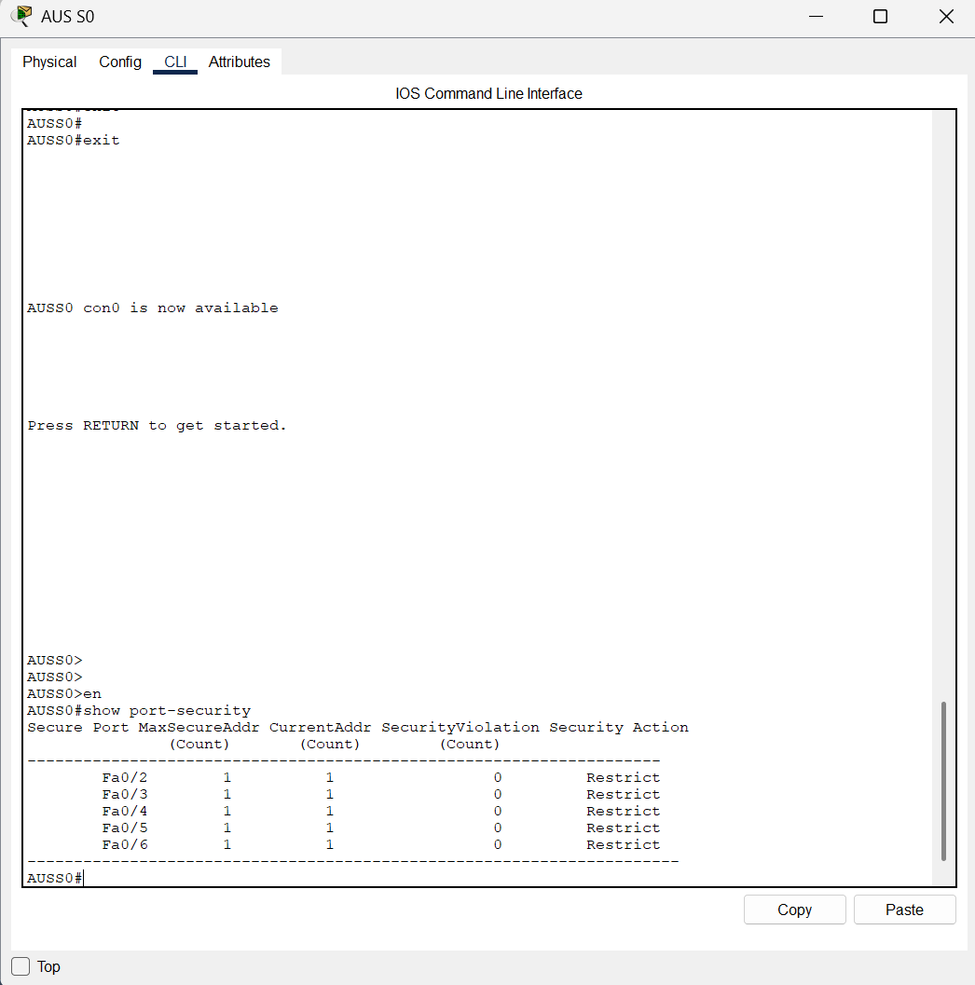

Basic Security Mechanisms 2

And next is the Secure Shell (SSH) implementation.

SSH Implementation:

**AUSS0**

This is the configuration to implement the SSH in AUSS0.

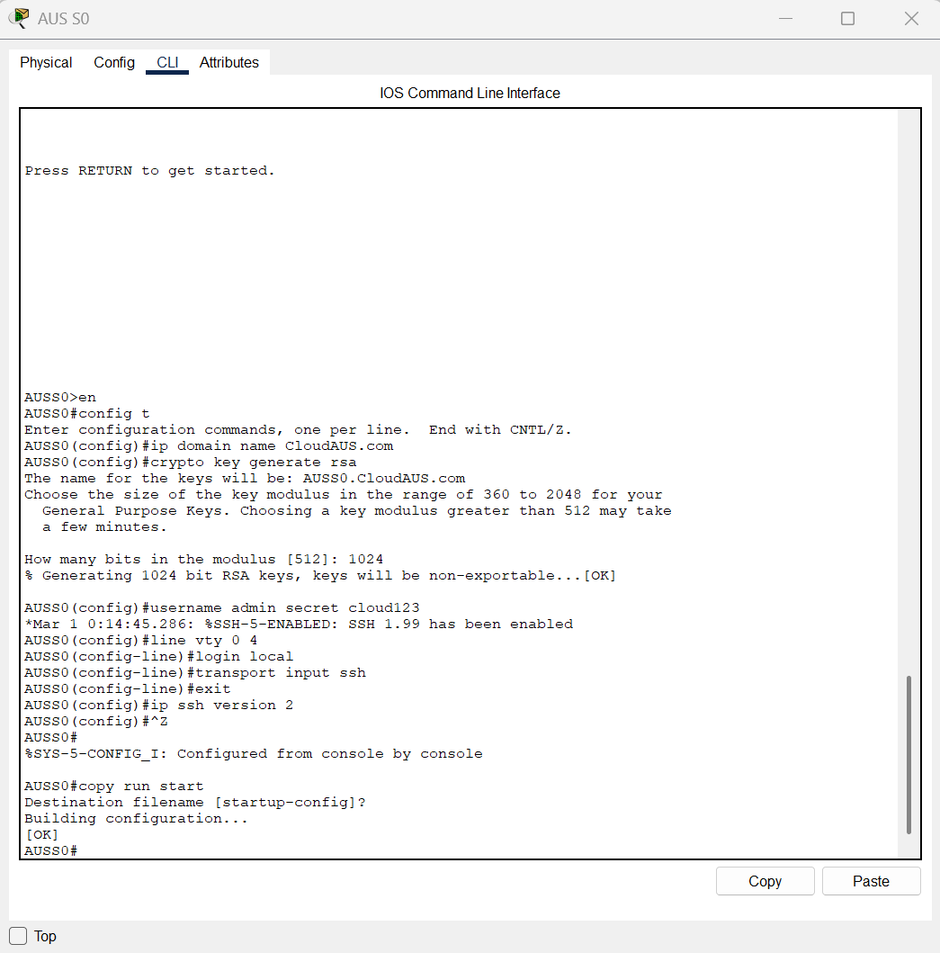

Basic Security Mechanisms 3

To verify that the configuration of the SSH in the switch is correctly implemented or not, open the laptop or pc in the IT department or WLC management PC and type in the following code with the username and password that just created.

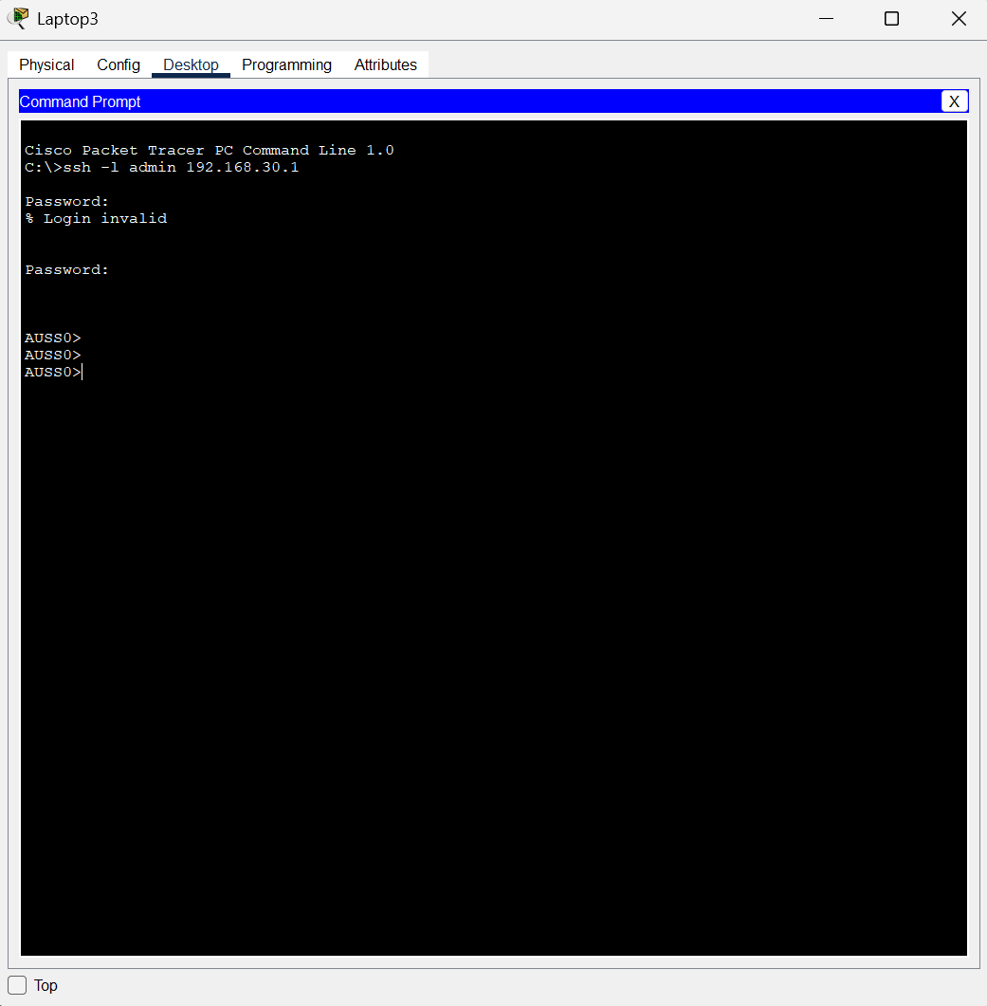

Basic Security Mechanisms 4

And it shows that the login is successful which mean that the SSH is implemented correctly.

**AUSR1**

This is the configuration to implement the SSH in the AUSR1(Australia Router 1).

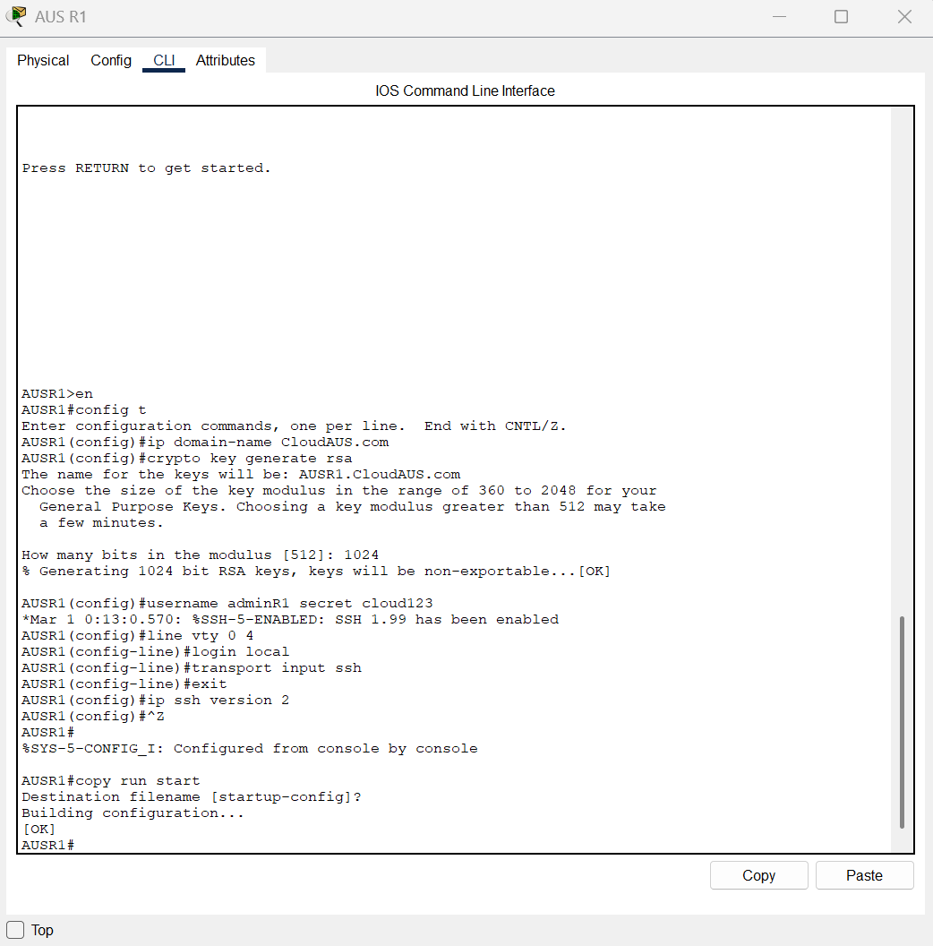

Basic Security Mechanisms 5

After completed the configuration in the AUSR1(Australia Router 1), try to login into the router.

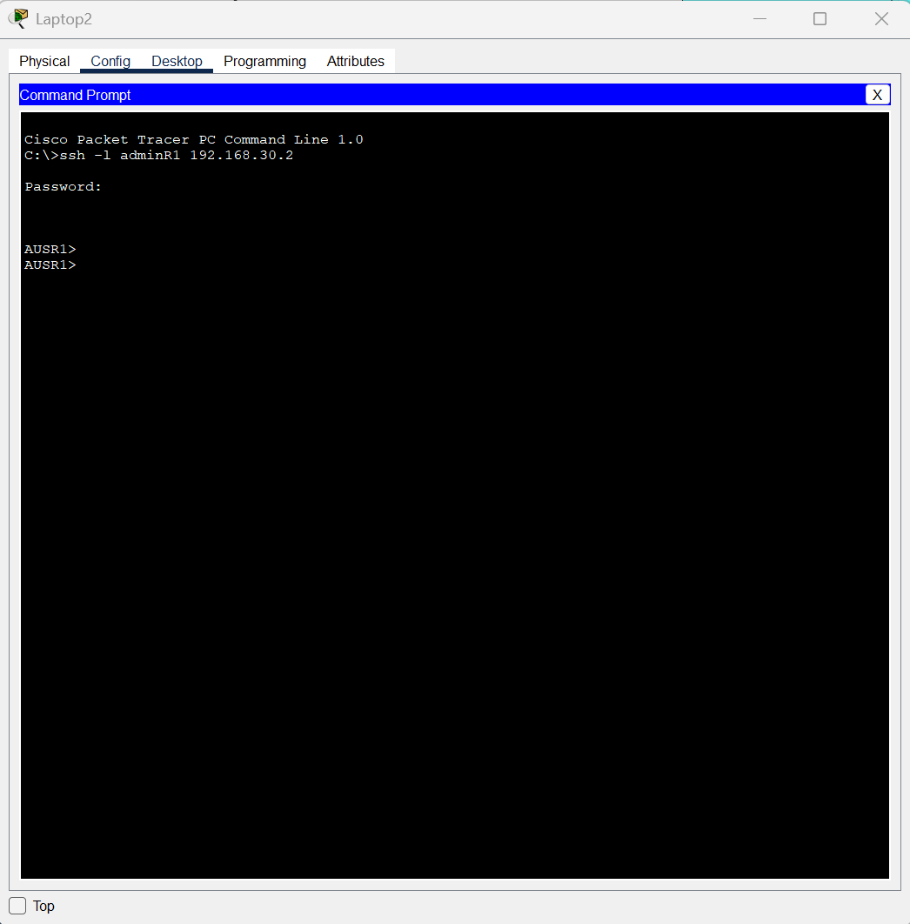

Basic Security Mechanisms 6

Disable Unused Port:

All of the unused switch ports has to be administratively shut down to reduce the potential entry points for attackers by a significant effect.

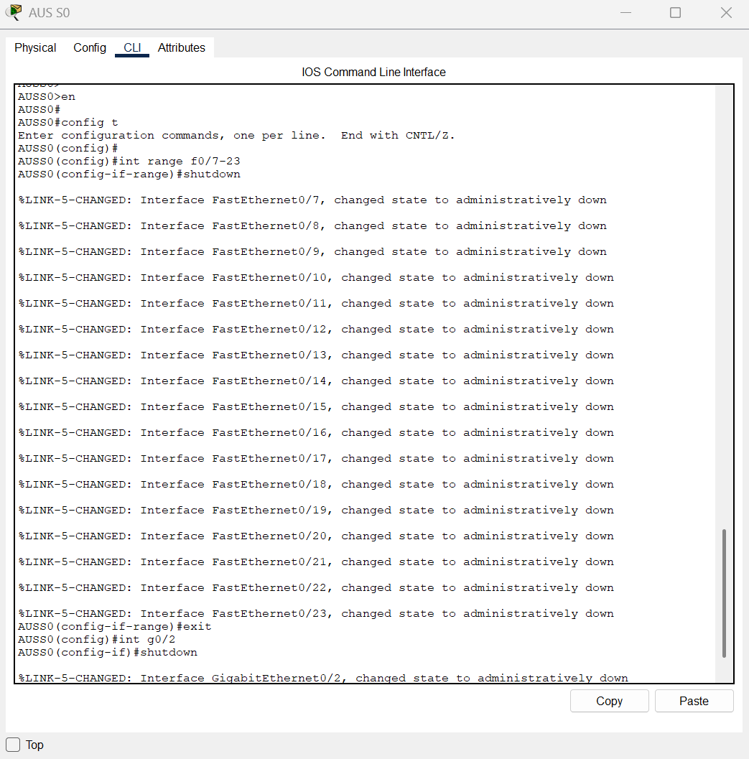

Basic Security Mechanisms 7

**Singapore Branch**

The basic security mechanisms use in Singapore part is the port security, disable unused port, and

SSH.

Disable unused Port:

**Switch 1 (server switch)**

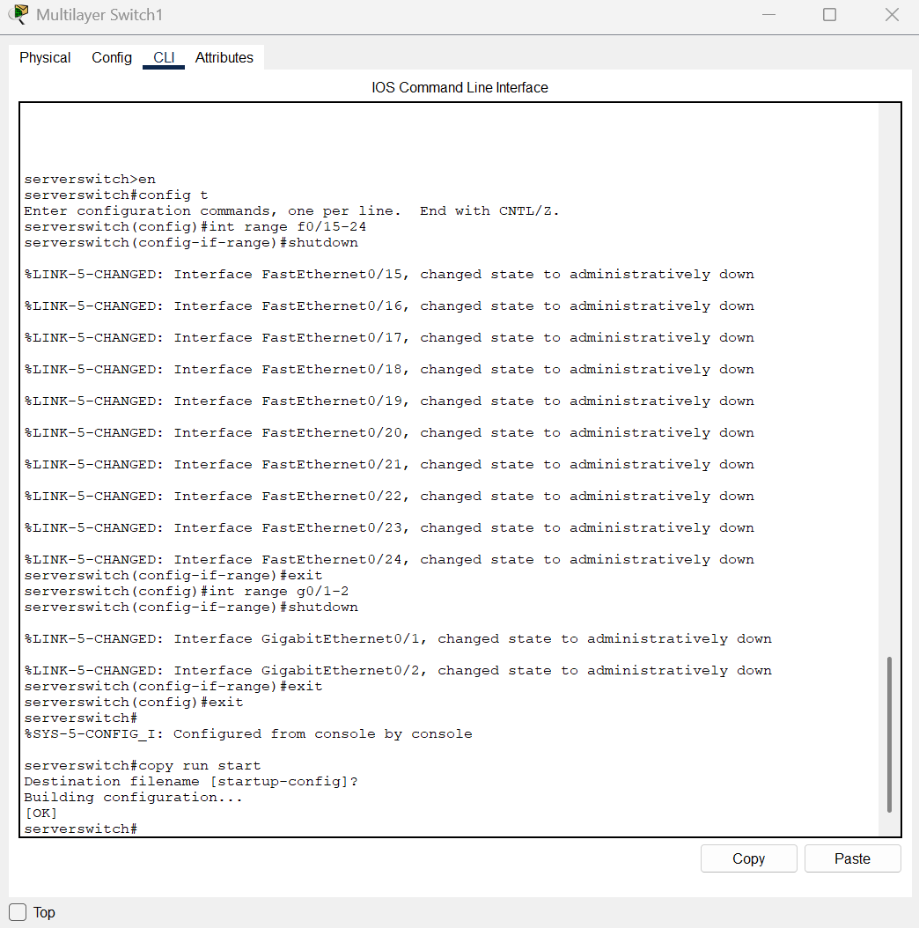

Basic Security Mechanisms 8

Port security Implementation:

This is the port security implementation of the Singapore Switch 1 (server switch).

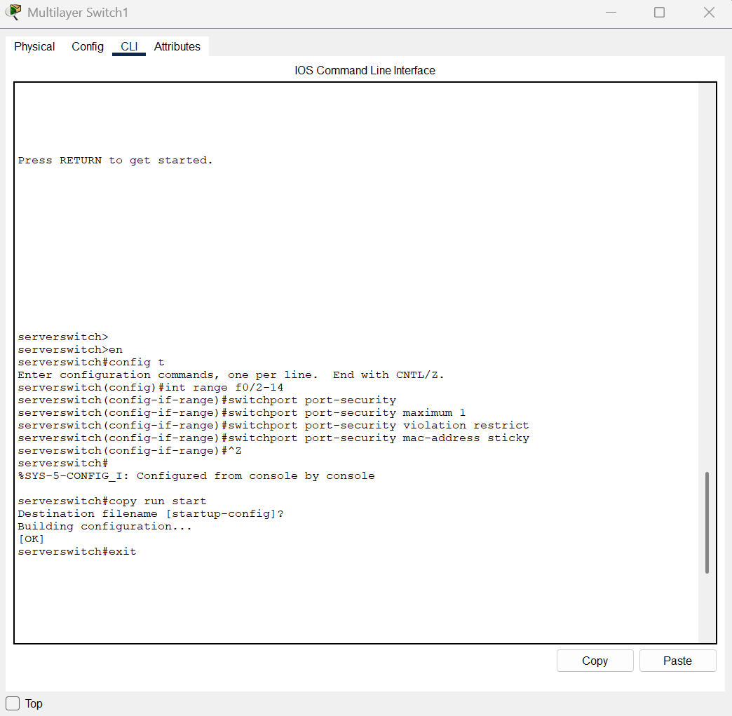

Basic Security Mechanisms 9

SSH Implementation:

This is the proof of the SSH has been successfully implemented in the network of Singapore.

**Switch 1**

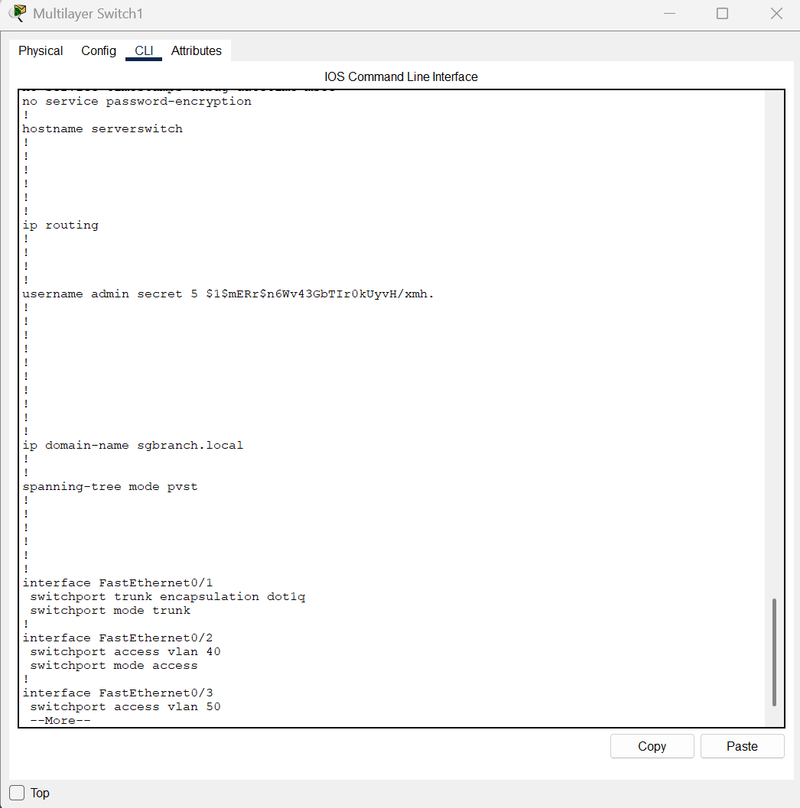

Basic Security Mechanisms 10

**Router 0 (routersg)**

This is the proof of the SSH has been implemented in the network of Singapore.

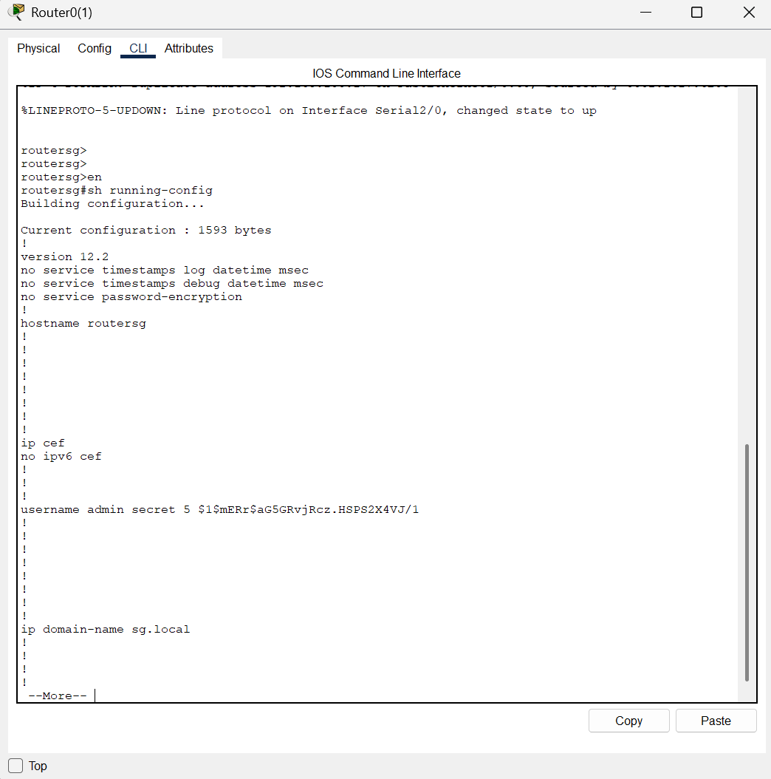

Basic Security Mechanisms 11

**KL Branch**

In KL Branch, port-security are implemented in all the switches, which are KLS1 (KL Switch 1), KLS2 (KL Switch 2) and KLS3 (KL Switch 3). SSH is the basic security mechanisms, so it has implemented all switches and routers in KL branch, which are KLS1 (KL Switch 1), KLS2 (KL Switch 2), KLS3 (KL Switch 3), KLR1 (KL Router 1) and KLR2 (KL Router 2). Moreover, all unused switch ports of all switches in KL Branch also will disable it.

Port-Security Implementation

**KLS1**

This is the configuration of port-security for KLS1.

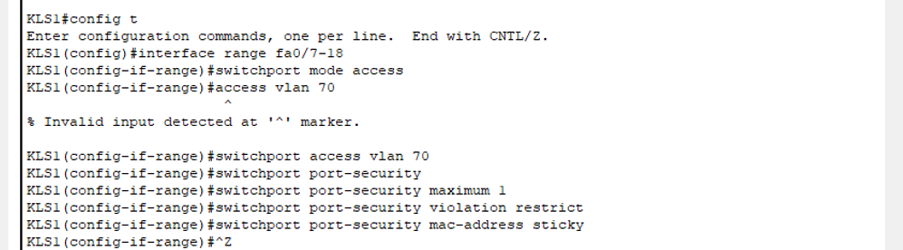

Basic Security Mechanisms 12

Make sure the port-security have been configured successfully and in the correct interfaces.

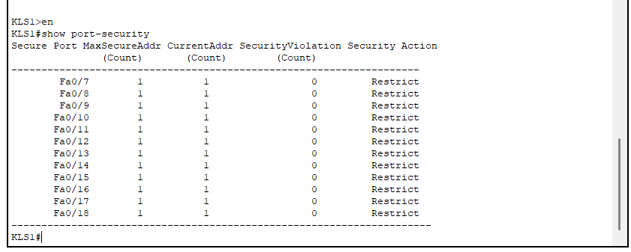

Basic Security Mechanisms 13

**KLS2**

This is the configuration of Port-Security for KLS2.

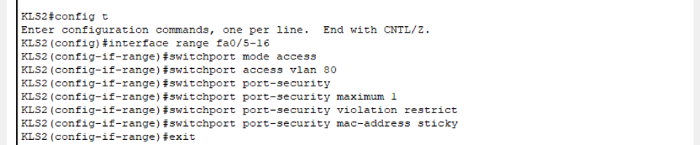

Basic Security Mechanisms 14

Here is the proof that the port-security have been added successfully.

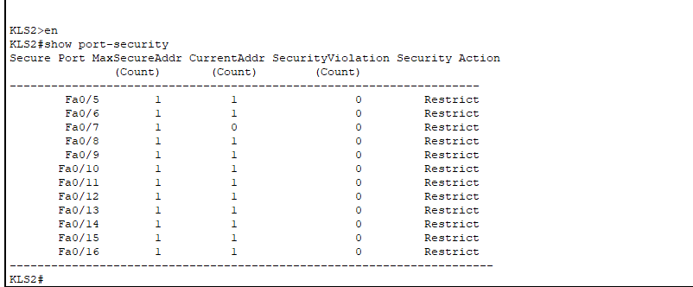

Basic Security Mechanisms 15

**KLS3**

This is the configuration of port-security for KLS3.

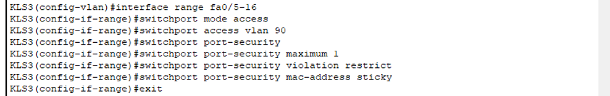

Basic Security Mechanisms 16

After the configuration, check for the status of port-security to ensure it is available.

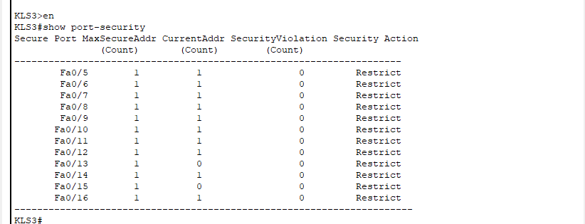

Basic Security Mechanisms 17

SSH

**KLS1**

This is the SSH implementation of KLS1, the name should be labelled clearly and select a suitable size of the key modules.



Basic Security Mechanisms 18

This is the proof that the SSH have been created in KLS1 successfully.

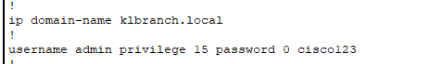

Basic Security Mechanisms 19

**KLS2**

This is the SSH implementation of KLS2.

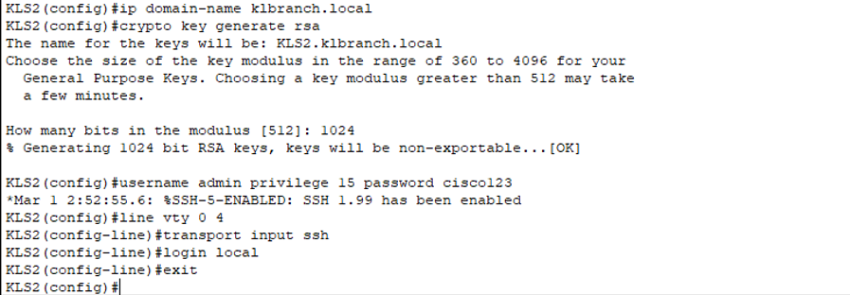

Basic Security Mechanisms 20

To make sure the SSH have been created successfully, it can check in the running-config.

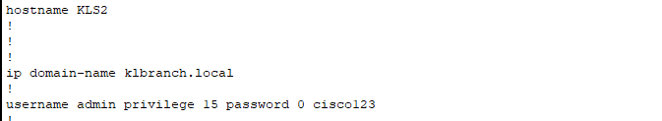

Basic Security Mechanisms 21

**KLS3**

This is the SSH implementation of KLS3.

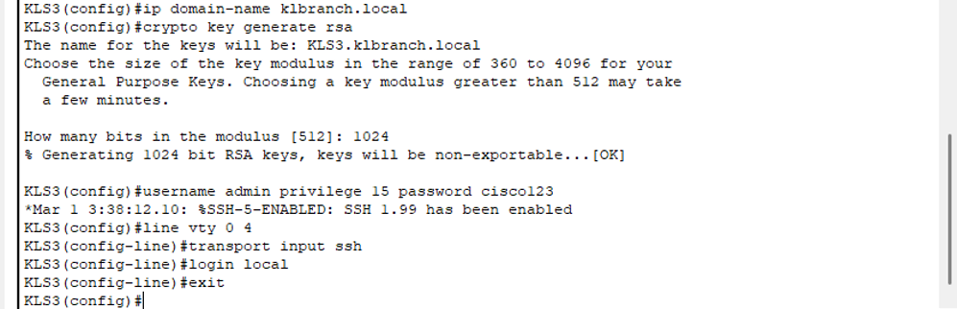

Basic Security Mechanisms 22

This figure is showing that SSH is available in KLS3

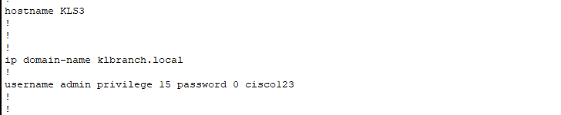

Basic Security Mechanisms 23

**KLR1**

This is the SSH implementation of KLR1,



Basic Security Mechanisms 24

Here is the proof of the SSH have added successfully in KLR1.

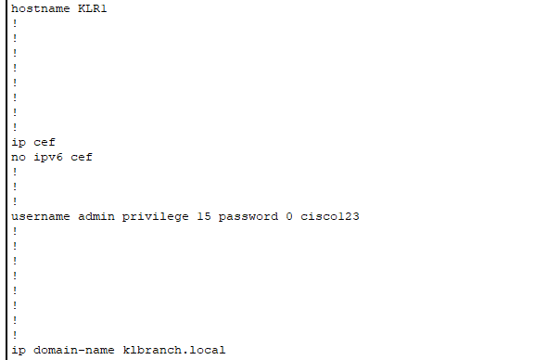

Basic Security Mechanisms 25

**KLR2**

This is the SSH implementation of KLR2



Basic Security Mechanisms 26

Here is the proof that the SSH have been installed successfully in KLR2.

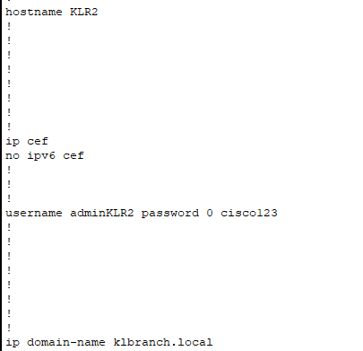

Basic Security Mechanisms 27

Disable unused port:

Disable unused ports can prevents unauthorized devices from connecting to the network, so it can reduce the risk of network attacks.

**KLS1**

As the int Fa0/5 and 0/6 have been used to connect with routers, so the unused ports is start from Fa0/19, it should be shut down by manually.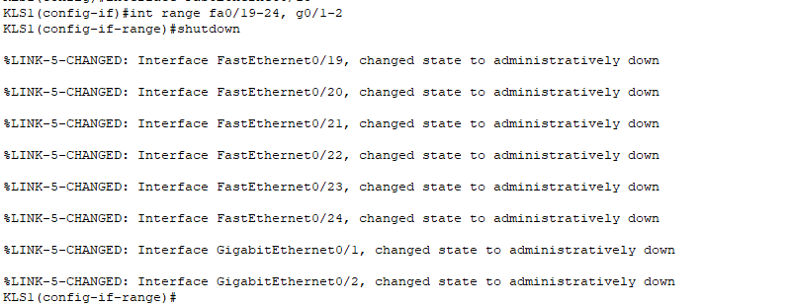

Basic Security Mechanisms 28

**KLS2**

All of the unused ports in KLS2 also have been shut down manually.

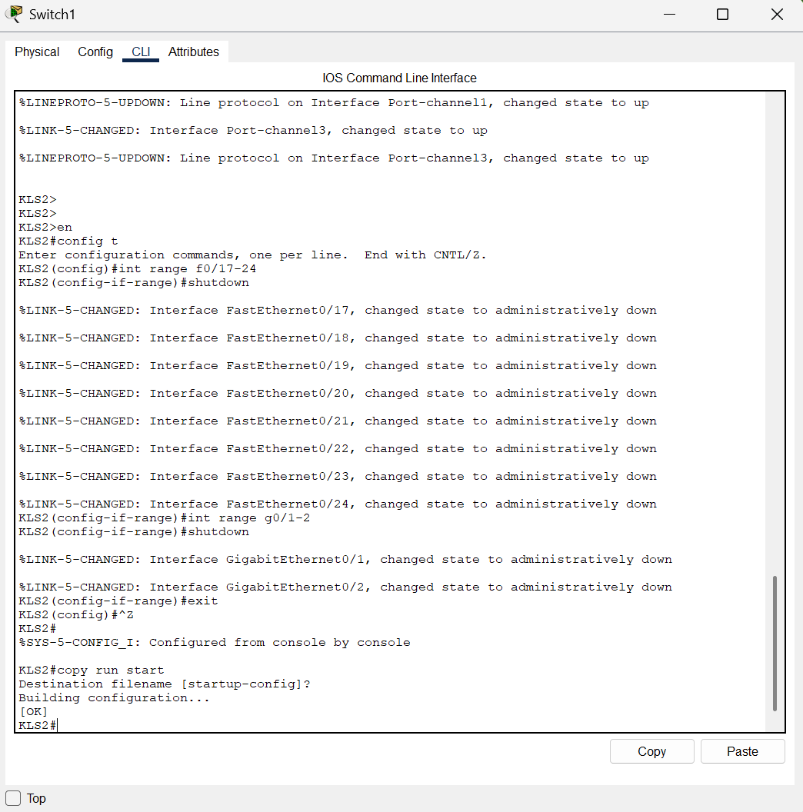

Basic Security Mechanisms 29

**KLS3**

In KLS3, its situation is same with KLS2, which the unused ports are start from FastEthernet0/17,

and both Gigabit Ethernet also are unused.

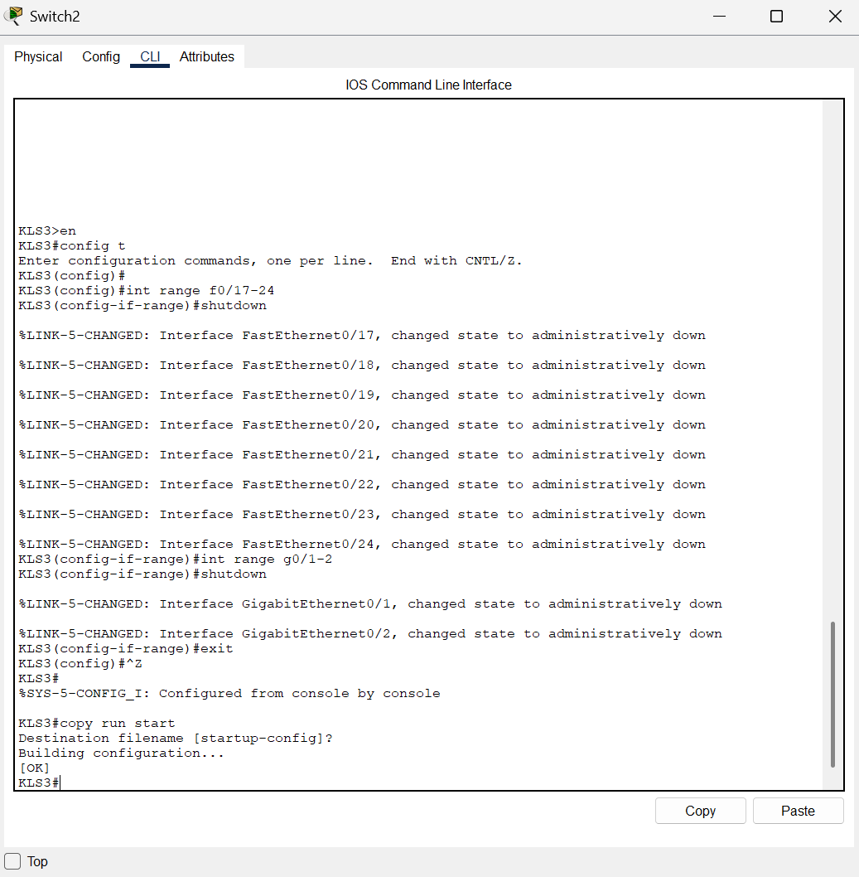

Basic Security Mechanisms 30

1. Recommendations to Improve the Security Mechanisms

Use Strong Password:

A strong password can easily enhance the security of the whole system such as using a strong password for the admin account or a strong password for the WLANs password which can let the attacker have to put a huge amount of effort to break the password.

Implement Access Control Lists (ACLs):

By configuring the ACLs to control and limit the network traffic between VLANs and to the sensitive areas (such as the server farms and between the departments), this can effectively prevent the unauthorized devices from invading through these paths and thereby enhance the security of the routers and switches.

Centralized Logging and Monitoring

After setting up Syslog and SNMP servers, network security personnel can monitor and record network events in real time. This helps security personnel to quickly detect the occurrence of a payment request and respond to the event in a timely manner.

Physical Security Controls

Increase the physical defence measures to make it more difficult for people to enter the management devices to prevent intentional people from attacking from the inside by force penetration.

1. Conclusion

In conclusion, the network upgrade project for Cloud Co is successfully implemented across the Kuala Lumpur, Australia, and Singapore branches. By redesigning the VLAN architecture and the implementing of advanced switching and routing student successfully improved the performance, security and manageability of our project. Through reviewing the lecturer's videos and studying online materials, so that student can learned the correct configuration method, refined our understanding, and applied it into the project, which allowed them to fully consolidate the practical skills in network configuration, basic security implementation and troubleshooting.

These experiences are very important to them because hands-on network solutions allow them to understand the difference between theory and practice. Therefore, these experiences enhance their problem-solving ability and teamwork. This experience is crucial to their future because it allows them to master the skills and knowledge required to face real industry challenges.

1. Work Breakdown Structure

|  |  |  |  |  |
| --- | --- | --- | --- | --- |
| Student Name | TP Number | Task | Percentage | Sign |
| Er Chen Liang | TP080254 | - WAN Configuration  - WLAN Architecture  - Introduction  - Basic Security Mechanisms Implementation – Australia branch  - Recommendation to improve the Security Mechanisms – Australia branch  - Australia branch  - Documentation  - Reference  - Ping commands to proof that the network is interconnected | 40% | ER CHEN LIANG |
| Chong Wai Kit | TP080388 | - KL branch  - Ether Channel Implementation  - HSRP Implementation  - Network Layout  - Basic Security Mechanisms Implementation – KL Branch | 30% | CHONG WAI KIT |
| Huang Xiao Shun | TP077723 | - Singapore branch  - Conclusion  - Configure Server Switch in Server Farm  -Basic Security Mechanisms Implementation – Singapore branch | 30% | HUANG XIAO SHUN |

1. Reference

*Cisco Networking Academy*. (n.d.). <https://www.netacad.com/launch?id=23f11c37-e40f-421c-9861-794f2b413fe8&tab=curriculum&view=a135343d-33ee-54d8-9ac0-bc8bbe7b674b>

*Gurutech Networking Training*CCNA DAY 75: WLC + VLANs | Wireless LAN Controller with Multiple VLANs Configuration - METHOD 3 <https://youtu.be/00gzQbIYJEw?si=YOnznksZl4K-FSAG>

*Gurutech Networking Training*CCNA DAY 74: Wireless LAN Controller (WLC) Configuration - METHOD 2 Using Cisco Packet Tracer <https://youtu.be/Mw2M6A_Twvg?si=xRnH7qPwBuov5kID>

*Gurutech Networking Training*CCNA DAY 63: Wireless LAN Controller (WLC) Configuration Using Cisco Packet Tracer | Cisco WLC <https://youtu.be/0dfm9ws9DXI?si=2VMg-XoSw1PtQOrR>

*Gurutech Networking Training*CCNA DAY 74: Wireless LAN Controller (WLC) Configuration - METHOD 2 Using Cisco Packet Tracer <https://youtu.be/Mw2M6A_Twvg?si=YTEBSTfHrKlUVrKn>

*Kent, K., & Souppaya, M. P.* Guide to computer security log management. <https://doi.org/10.6028/nist.sp.800-92>